Literature report

Research Plan phD

Mylene Receveur

Table des matières

Introduction 4

Coal mining industry 5

Mine-water as geothermal resources 6

Existing projects 6

Extraction systems 8

Heat sources in mines 9

Mine water temperatures 9

Geothermal Gradient 9

Mine water stratification 10

Exothermic reactions 10

Faults and fluid flow 11

Reservoir properties 12

Thermal properties 12

Hydraulic and material properties 12

Thermal energy potential 13

Geological background 15

Geological formation 15

Bedrock geology 15

Basin stratigraphy 16

Structure and Basin history 18

Magmatism 19

Geophysical Data 21

Aquifer systems 22

Carboniferous sedimentary aquifers not extensively mined for coal 23

Carboniferous sedimentary aquifers extensively mined for coal 24

Groundwater chemistry 25

Geothermal data 25

Hot sedimentary aquifers (HSA) 27

Hot Dry Rocks and HHP Granite 28

Minewater temperature in the UK (see appendix XXX) 29

Mine conceptual models 30

Mine types 30

Pillar and stall 30

Longwall mining 31

Estimation of void volume in mines 31

Mine structure 33

Modeling 35

Introduction 35

Analytical solutions 35

Numerical solutions 35

Previous studies 36

Heat transfer in mine tunnels, Ghoreishi Madeish et al. (2012) 36

Heat transfers in longwall panel (Goreishi Madiseh and Abbasy, 2015) 37

Dual-porosity medium (Guo at al., 2018) 38

Combined 3D porous medium and 1D pipe flow (Raymond and Therrien, 2008) 39

Combined 3D/2D/1D model of porous medium and pipe flow (Renze et al., 2009) 40

Hamm and Bazargan Sabet (2010) 41

Malolepszy (2015) 42

Andrés et al. (2017) 42

Boundary conditions 43

Initial conditions 43

Data requirements 43

phD research project 46

Research points 46

Potential case studies 46

Modeling approach 46

Modeling tool 46

Model set up 47

Appendix 49

Heat equations 49

Available heat 49

Governing equations 49

Conduction in 1D 49

Bernouilli equation for pipe flow 50

Analytical approaches 50

Lauwerier-Pruess-Bodvarsson model (Lauwerier, 1955; Pruess and Bodvarsson, 1983) 50

Rodríguez and Díaz (2009) model 51

Temperature correction for paleoclimatic effects 52

Mine voids definitions 55

Void space in workings $Vz$ (Rogoż 1974; Rogoż et al. 1999) 55

Void space in pores in dewatered sandstone strata Vg 55

Void space in tunnels, drifts, and galleries Vk (Rogoż et al., 1999) 55

Voids in fractures induced above workings Vszc (Rogoż et al., 1999) 55

Mine temperatures 56

# Introduction

* Heat released by the earth geothermal flux and mineral oxidation in mines is carried by groundwater that circulates within large voids inherited from the mining activities (Ghomshei and Meech,2003).
* Water rebound after closure of the mine and the cessation of dewatering generally lead in the flooding of the workings, which can result in the discharge of contaminated water to the surface environment (Robin et al., 2008). To mitigate the impacts of contamination by mine waters, the Coal Authority have been responsible for the implementation of mine water treatment systems in the UK (Younger et al., 2004). Most of mine discharges in South wales coalfields are gravity driven (Robins et al., 2008). At ‘Six Bells’ (Vivian Colliery), mine water is pumped from a 217m deep borehole and redirected to a treatment scheme (Farr et al., 2016). In the UK, about 3000 L/s of mine water are pumped from more than 50 abandoned coal mines (Banks et al., 2009), representing ~100 MW of potential low enthalpy heat energy (Coal Authority, 2010). In addition to provide low-carbon energy, using mine-water as a source of energy is an opportunity for the Coal Authority to decrease some of the expenditure by selling heating or cooling services, the most cost-effective geothermal systems being those already being pumped for dewatering or treatment purposes (Loredo et al., 2016).

# Coal mining industry

Coal was first mined in the UK by the Romans, in Northumberland, after which mining was abandoned for a thousand years (Hall, 1981). Some traces of mining have been found during the 12-13th century, but until the end of the 15th century, almost none was known about the coal mining potential of the Scottish lands. The first mines only emerged during the 16th Century and increased in number uring the 17th. In the early times of mining, coal was extracted from shallow mines, using the “pillar-and-stall” method. The invention of the Newcomen steam engine in the early 18th revolutionized the mining industry. This engine, which was first installed at a coal mine at Dudley Castle in Staffordshire in 1712, allowed the efficient dewatering of deeper galleries and the development of deep mining. Coal production signifcantely increased until the First World War. During both the First and Second World War, collieries were taken under control of the government but all the mines remained under property of private companies, most of them being small companies. In 1947, the Coal Industry Nationalisation Act 1946 announced the nationalization of the coal industry. The National Coal Board (that became the British Coal Corporation under the the Coal Industry Act 1987) was created and acquired about 900 collieries from about 800 private companies (i.e. NRS Scotland).

* Alloa Coal Company 1835-46 (CB24)
* Archibald Russell Ltd 1901-46 (CB12)
* Bairds and Dalmellington Ltd 1898-1952 (CB4)
* Coltness Iron Company Ltd 1885 (CB11)
* Darngavil Coal Company 1943-45 (CB22)
* East Wemyss Coal Company 1891-1948 (CB1)
* Fife Coal Company 1872-1961 (CB3)
* Fordell Colleries 1798-1940 (CB30)
* Lochgelly Iron and Coal Company 1847-1953 (CB2)
* Lothian Coal Company 1741-1919 (CB9)
* Niddrie and Benhar Coal Company Ltd 1880-1937 (CB18)
* Shotts Iron Company Ltd 1871-1946 (CB21)

In 1979, 70% of the coal sales in Britain were used for electricity generation (Manners, 1981), produced from deep mines in 223 NCB collieries. Commitment of the government to increase shares of oil and nuclear for electricity generation and the increase in steel industry then lead to a drop in the demand for coking coal, while the importation of coal became cheaper. About 85 collieries closed between 1958 and 1959. While about 700 000 miners produced 210 Mt of coal in 1956, less than 290 000 workers were producing 136 Mt at 292 collieries in 1971. After the 1972 miner’s strike and 1974 Plan of Coal, £3000 investments were engaged by the NCB for the development of new collieries. The announcement of mine closure in 1984 led to the 1984-1985 national strike, after which 23 mines closed and 12 000 miners left the mining industry. In 1992, only 50 mines were still opened.

Following the 1991 Water Resource Act, the Coal Authority was created in 1994 under the Coal Industry Act 1994. The administrative functions of the BCC were transferred to the Coal Authority, whose role includes the management ofe the pollution from abandoned mines, excepting those passed to the private sector through leases (Hansard, 1994), and the economic assets were privatized. Only 15 pits were still in production by the time of the privatisation. The 1996 Environment Act then dictated that mine operator would be responsible for uncontrolled drainage of water from any mine abandoned after 1999.

# Mine-water as geothermal resources

Abandoned flooded mines workings constitute potential low-temperature geothermal reservoirs that can be used for energy storage and production (Adams and Younger, 2001). During mining, the extraction of coal from laterally distributed seams and the construction of shafts, roadway and galleries tends to form a complex network of interconnected voids that get flooded after the closure of the mine, when dewatering stops. This forms ‘mine aquifer’ of artificially enhanced aquifers, from which hot water can be extracted at relatively high rates (Malolpsezy, 2015). In addition, connections between the mine workings and surface features (i.e. drains, shafts, streams) offers the potential for rapid recharge in response to precipitation events (Farr et al., 2016).

Valorizing the geothermal potential of water stored in abandoned coal mines has been of growing interests in the UK (Banks et al., 2004). Thanks to their broad-based accessibility and their location closed to densely-populated areas, coal mines inded have a great potential for geothermal exploitation (Ruhaak and Renz, 2010). The heat released from the earth and contained in mine water represent a valuable low-carbon resource that can be used for both space heating/cooling or domestic hot water heating in both single household or district heating, using Ground Source Heat Pump (GSHP) technology (Farr et al., 2016).

### Existing projects

Several projects using mine water-based heat pump systems have been implemented worldwide, about 96% of them being implemented at underground mines. This includes the Oranje Nassau Colliery in Heerlen, The Netherlands (Bazargan et al., 2008; Ferket et al., 2011; Johnston et al., 2008; Verhoeven et al., 2014); the Barredo-Figaredo coal mines in Asturias, Mieres, Spain (Jardón et al., 2013; Andres et al., 2015), the Nowa Ruda mine in Poland (Malolepszy, 2005, 2012), the Springhill coal mine in Nova Scotia, Canada (Jessop et al., 1995), and in the US (i.e. Park Hill, Missouri; Houghton, Michigan). The Vital Álvarez Buylla Hospital in Spain uses mine water from the abandoned and flooded Barredo-Santa Bárbara system of coal mines (Carboniferous in age) in Mieres, Asturias, Spain, to supply energy for the heating and air conditioning system. Water pumped out of the Barredo mine shaft yields up to 3.5 MWt using heat exchanger system. In Houghton, mine water in pumped at the Keweenaw Research Center (KRC) from 300 feet below the surface. In Heerlen, The Netherlands, 5 wells drilled down to 700 m depth into coal mines are used to provide heat/cooling to 350 dwellings, commercial floor space and community buildings.

Additional studies of the potential for mine-water based geothermal systems have been performed for several coal mining field. This include the Plzenska coal basin in Czech Republic (Baier et al., 2011), the Vouters coal mine in France (Hamm and Bazargan Sabet, 2010), the Gaspe mine in Canada (Raymond and Therrien, 2006), in the USA (Pittsburg coal mine) or the Krimich II coal mine (Uhlik and Baier, 2012). In addition to coal mines, the geothermal potential of potassium and uranium mines have also been assessed in Germany (Renz et al., 2009), Norway (Cu, Zn and S Folidal mine and Kongsberg silver mine), in Hungary (recsk mine), at the Pribram region in Czech Republic (Baier et al., 2011), in Poland (Nowa Rudat coal mine) or in Canada (Con gold mine; Ropak Can Am Coal mine, Nova Scotia)

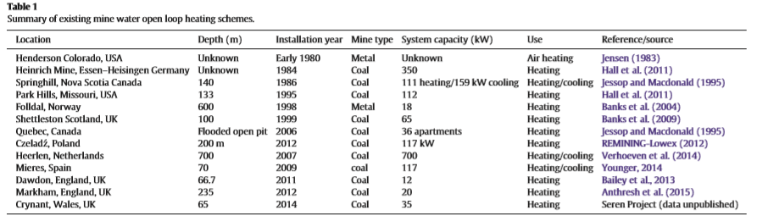

Summary of existing mine water open loop heating schemes (Farr et al., 2016)

In the UK, ground source heat pump technology was first implemented at a temporary pilot site in Mossend, Scotland, in 1992. Two permanent open loop mine water-based ground source heating schemes were then commissioned in 1999-2000 in Shettleston (used to heat to 16 dwellings over an area of 1600 m² near Glasgow) and in Lumphinnans, near Cowdenbeath in Fife (Banks et al., 2009). There, 12°C and 14.5°C water is pumped at a rate of 5-10 l/s from about 100 and 172 m, respectively. The water circulates through the heat pump before being reinjected at a temperature of 3°C in the Carboniferous strata, via 50 and 60 m deep boreholes located 20 and 100 m away from the production ones (Banks et al., 2004). The table below summarizes the mine-water projects listed in the UK.

In Shettleston, where at least 6 seams have been mined, the water is heated to 55°C through a heat exchanger, to provide heat to 16 dwellings. In Lumphinnans, at least 11 seams belonging to the Lower Carboniferous Limestone Coal Group have been mined (including the uppermost Lochgelly Black Band Ironstone, the Seven Foot Seam, the Kelty Main, the Jersey or Diamond Seam and the Swallowdrum (Burke 1999)).

|  |  |  |  |  |
| --- | --- | --- | --- | --- |
| Year | Project | Location | Power | Source |
| 2011 | Feasible study | Taff Merthyr mine water treatment works | 220 kW | Manju et al., 2011 |
| 2013 | Coal Authority demonstration system commissioning | Dawdon, County Durham | 12kW | Bailey et al., 2013 |
| 2014 | Installation mine water heat pump system pumping a 11.5 C water from 65 m deep in the Carboniferous Coal measures strata | Crynant, Dulais Valley, South Wales | - | Farr et al., 2016 |
| April 2015 | Installation of Heat Pump system in a colliery pumped since 1996 for water management purpose (14 C mine water) , using either a closed loop heat exchanger submerged in the aeration pond of the treatment system, or an open-loop shell-and-tube heat exchanger using water pumped from the Hope Shaft. | Caphouse Colliery | 10-kW | Burnside et al., 2019 |
| 2018-2020 | UK Geo-energy Observatories Project | Glasgow | - |  |

The UK Geoenergy Observatories Project aims to enable the UK researchers to study the geothermal characteristics of flooded coal mines and the potential for using hot water as a renewable heat energy resource. The Glasgow Geothermal Energy Research Field Site is located on the western side of the central Coalfield of the Midland Valley of Scotland, on the site of the former Farm Colliery closed in 1921. The mine is located within 300 m of bedrock strata of the Scottish Upper, Middle and Lower Coal Measures formation. A total of 12 boreholes have been drilled in Dalmarnock and Rutherglen’s Cuningar Loop. Data acquired since the drilling of the first well in 2018 (i.e. temperature, water movement, geochemistry, environmental monitoring…) will allow getting a better understanding of how the water moves around the abandoned mine workings over time and the extent of the interconnections between the mines of the Glasgow and Lanarkshire coalfields, but also estimating how much heat can be extracted from waters in the abandoned mines beneath the city.

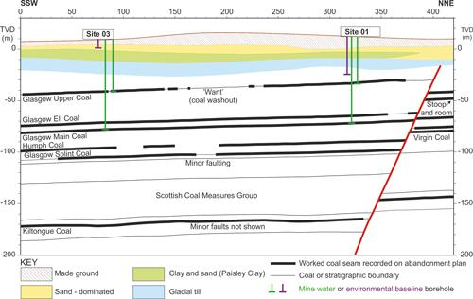

*Cross-section of the geology in the Cuningar Loop area with the planned borehole target depths shown, UK Geoenergy Observatory in Glasgow. Note that the thick black lines represent areas recorded on abandonment plans as mine workings. TVD=true vertical depth relative to Ordnance Datum, top X-axis is in metres*

BritGeothermal is promoting new approaches to the national planning policy, licensing of heat and regulation of subsurface use to ensure that mine energy potential is considered when planning new developments. This group is also investigating the mine energy potential of a number of former coalfields. It is hoped that the Glasgow Geothermal Energy Research Field Site (BGS, 2018) will significantly reduce subsurface, geoscientific uncertainties and risks, raise awareness and stimulate the market for this low-carbon energy source.

In addition, the recent Trailblazing project in Caerau, South of Wales plans to use underground mine water from the workings of the old Caerau colliery, which closed in the late 1970s, to heat houses, a school and a church. Bridgend Council in Wales is working to deliver a large district heating system that will initially supply heat to around 150 homes (Monaghan, 2019).

### Extraction systems

Energy can be extracted from hot mine water using GSHP technology, using open loop or closed loop systems (Huttrer, 1997; Banks, 2016; Ghomshei, 2007; Hall et al., 2011…).

Mine-water heat systems are generally operated open-loop ground-source heat system. In open-loop systems, the 12-20C water pumped from flooded mine shafts and galleries through boreholes circulates through a heat pump-heat exchanger unit before being discharged to a water treatment system (e.g. Caphouse Colliery, UK, Burnside et al., 2015; Parker, 2011), to surface water ponds (e.g. Mieres, Spain), or back to the mine via another borehole or shaft (e.g. the Shettleston & Lumphinnans, Scotland, Banks et al., 2009). In a standing column arrangement, the water pumped from a flooded abandoned mine shaft is reinjected back the mine at a different depth through the same shaft after its passage through the HP exchanger unit (e.g. Markham Colliery, Bolsover, UK, Athresh et al., 2015). Open loop systems generally have high efficiency of thermal exchanges compared to the other systems as the fluid carrying heat directly enter into contact with the surrounding hot rock (Luo, 2014).

In a closed loop system, a calorific fluid circulates through a heat exchanger submerged in the flooded mine void, via a heat pump (e.g. shaft of Folldal Mine, Norway - Banks et al., 2004; minewater treatment lagoon, Caphouse Colliery, UK, Banks, 2016.)

# Heat sources in mines

## Mine water temperatures

Temperature in mines is related to a combination of heat source and transfer processes, that include the geothermal gradient/heat flow, the circulation of water through preferential pathways (i.e. connecting tunnels, mined levels, incoming water…), heat exchange with the walls (slow process) or local heat generation by decay of radioactive elements. The internal heat production *A* (µW/m3) can be expressed as:

$$A={10}^{-5}ρ \left(9.52\left[U\right]+2.56\left[Th\right]+3.48\left[K\right]\right)$$

The formula is from Bucker and Rybach (1996) and the average values are taken from Turcotte and Schubert (2014), with $ρ$ the average rock density and [U], [Th] and [K] the concentrations of Uranium (ppm), Thorium (ppm) and Potassium (%) (Velez et al., 2018).

During the mining period, air ventilation is moreover implemented in underground workings to minimize the stresses on the equipment and ensure safe conditions for the miners, resulting in temperature decrease (Anderson and De Souza; Malolespzy, 2015). The rate of cooling of the rock mass resulting from ventilation has been estimated in the study by XXX using measurements of rock temperatures taken during periods of mining. Cooling load requirements can be expressed as:

$$Q=M_{f} ×\left[\left(h_{1}-h_{2}\right)-\left(W_{1}-W_{2}\right)× h_{w2}\right]$$

With $M_{f}$ the mass flow entering a zone, $h_{1}$ and $h_{2}$ the enthalpy entering and leaving the zone, respectively, $W_{1}$ and $W_{2}$ the specific humidity entering and leaving the zone, respectively, and $h_{w2}$ the specific enthalpy of water.

Anomalous heat, where the water temperature is greater than the ground temperature, can be related to additional mechanisms such as free convective mixing of water from different level in open vertical shafts (Krige, 1939), forced water circulation, recharge from greater depth through faults, trapped heat below low conductivity “cap” rock above a heat source, heat refraction (i.e. inclined strata) or exothermic chemical reactions (i.e. mineral oxidation). In the latter case, it is assumed that the heat generated is mainly taken by the water, limiting the accumulation of heat in the rocks.

## Geothermal Gradient

The geothermal gradient represents the rate of increase of temperature with depth (C/km). In deep mines, it is assumed to have the greatest contributions on the rock temperature (Anderson and De Souza). The geothermal gradient, and thus the temperature at a given depth, depends on the heat flow and the rock thermal conductivity and can be impacted by groundwater flow. Available temperature data measured in onshore boreholes in the UK are reported in the Geothermal Catalogue for the UK (i.e. Burley et al., 1984; Rollin et al., 1987), or from Hard Copy temperature logs in the BGS archive, and the BGS National Petrophysical Data Archive. New heat flow maps for the UK have been created by Busby et al. (2011) combining those data sources, including data from 390 deep (> 1000m) boreholes.

## Mine water stratification

According to Burnside et al. (2019), the heat flow in flooded mines is dominated by advection of heat. Water bodies tend to form density-related stratification resulting from the mixing of cold meteoric water and warmer saline water originating from depth (Nuttall and Younger, 2004). Hamm et al. (2010) also showed using numerical models that free convection is the main heat transfer process in mine shafts through efficient intra-well mixing that fixe the temperature along the shaft close to the average of the temperatures at the top and bottom (in case where only one gallery is crossed at the bottom of the shaft). The presence of several galleries intersecting the shaft at different levels induces local water mixing and allows the establishment of a higher temperature at the bottom of the shaft.

Following long periods of abandonment, mine waters also tend to become geochemically stratified, with better-quality water generally lying above poorer-quality ones (Wolkersdorfer, 2008; Nuttall & Younger, 2004). Geochemical stratification in the Heerlen mine, the Netherlands, suggested the infiltration of different water types at different depth during and after mining (Ferket et ak., 2011). There, electrical conductivity (EC) measurements were used as a useful marker for distinguishing between shallow and deeper sources.

Pumping water from mine generally encourage turbulent water mixing within the mine, which can destroy density-related stratification in wells and reduce the water quality (Burnside et al., 2019). The impact of this induced mixing dynamics in the Hope Shaft, Caphouse Colliery was studied by Burnside et al. (2019) using temperature, conductivity, pH, major ions and stable isotopes of O, H and S to understand the potential of the mine water body for sustainable heat generation. Results indicated no significant change in the water geochemistry during the study period, but the long-term chemical analysis from archive data revealed a general mine water quality recovery trend following the mine closure and the subsequent flooding. According to Hamm et al. (2010), temperature decrease due to forced convection is rather limited when water is pumped from the bottom of the shaft, and depends mainly on the pumping rate.

## Exothermic reactions

Mine water generally contains a high concentration of iron that result from the oxidation of pyrite contained within the coal by oxygenated mine-water. Pyrite oxidation and hydration occurs when water is lowered by pumping, and can be expressed as (Sherwood, 1987):

${FeS}_{2}+\frac{15}{4}O_{2}+\frac{7}{2}H_{2}O→{Fe(OH)}_{2}+2 {SO}_{4}^{2-} {2H}^{+ }$ (1)

${FeS}_{2}+\frac{7}{2}O_{2}+H_{2}O→{Fe}^{2+}+2 {SO}_{4}^{2-} {+2H}^{+}$ (2)

${Fe}^{2+}+\frac{1}{4}O_{2}+{+H}^{+}→{Fe}^{3+}+ {\frac{1}{2}H}_{2}O$ (3)

with eq.1 representing the full Acid Mine Drainage equation, eq. 2 the oxidation of crystalline pyrite to ferrous iron and eq. 3 the oxidation to ferric iron. The pyrite oxidation reaction given by Farr et al., (2016) is

$${FeS}_{2}+\frac{7}{2}O_{2}+H_{2}O→{Fe}^{2+}+2 {SO}_{4}^{2-} {2H}^{+}$$

Most of the geochemical reactions in mines, including oxidation reactions are exothermic, which contribute to the overall temperature of mine waters (Farr et al., 2016). Using discharge value at Ynysarwed with a total iron concentration of 0.001377 mol/L (Langmuir, 1997; Atkins and Paula, 2006), Farr et al. (2016) estimated that pyrite oxidation reactions would generate a temperature increase of 0.5 K/L of water.

$$∆H_{r}= -1538.4\frac{kJ}{mol}$$

$$∆T= \frac{∆H}{c_{p}}=\frac{-1538400\frac{J}{mol} ×0.001377\frac{mol}{L}}{55.5\frac{mol}{L}of water ×75.29\frac{J}{mol}}= -0.507°K/L$$

With, $∆H \left(\frac{kJ}{mol}\right)$ the enthalpy of overall reaction (<0 means exothermic), $Cp$ is molar heat capacity of water and ∆T the temperature released to the water.

One of the main issues in extracting energy from mine water is the risk of precipitation of iron and manganese oxyhydroxides on the surface environment or in heat exchangers (Banks et al., 2009). Precipitations in heat pumps might cause rapid clogging of the system that would imply high maintenance costs.

$${4Fe}^{2+}+10H_{2}O+O_{2}<- >{4Fe(OH)}_{3}+{8H}^{+}$$

$$4{Mn}^{2+}+4H_{2}O+2O_{2}<- >{4MnO}_{2}+{8H}^{+}$$

Despite the ferruginous characteristics of the mine water in Shettleston, the success of the geothermal scheme there was attributed to the efficiency of the sealing pipework-heat exchanger unit, avoiding any contact between the mine water and the atmosphere (Banks et al., 2009). The clogging tendency of the boreholes in some schemes (i.e. Lumphinnans, Banks et al., 2009) could on the contrary be due to e.g. the exposure of the mine water to atmospheric O2/CO2 or CO2 degassing of the mine-water resulting from pressure reductions in the pumping system, leading to calcite and iron hydroxide precipitation. Changes in the abstracted mine-water temperature in heating/cooling schemes might moreover lead to a decrease/increase in the rate of biotic, abiotic iron oxidation and biofilm formation. Thus, Banks et al. (2009) suggested that calcite and ferric/manganese oxyhydroxides precipitation can be minimized by avoiding dewatering of the flooded mine horizons, by setting recharge below the water table in the reinjection well and maintaining a constant pressure.

## Faults and fluid flow

Faults can have substantial impact on subsurface temperatures due to their influence on rock permeability. They can either act as a highly conductive flow pathways, allowing water recharge from surface or from the coast (i.e. Highland Boundary Fault), carrying heat through convective flow, or as a flow barrier (Browne et al., 1987).

Different lithologies are likely to deform differently when subjected to stress, resulting in different permeability structures within fault zones.

|  |  |  |  |
| --- | --- | --- | --- |
| Rock type | Brittle rock | Clastic rock | Carbonates |
|  | Breccia / joints | Deformation band (<2cm thick low permeability bands) in fault core/damage zone  (Antonellini et al., 1995; Aydin, 1978). | Increase in permeability by dissolution of rock along the faults (Billi, 2005)  Mineral precipitation:  decrease in permeability (Micarelli et al., 2006) |
| Damage zone | Extensive around the fault core (10 – 1000m thick perpendicular to the fault strike)  high hydraulic conductivity: increasing the bulk permeability of the area (Bense et al., 2013) | Fractures are less common  If presence of clay: forms low permeability sealing rock in the fault core (Yielding et al., 1997; Gibson, 1998) | Chemical reactions induced by groundwater inflow. |

## Reservoir properties

### Thermal properties

The specific heat capacity $C_{p}$ (J/K), the thermal conductivity $λ$ (W/m.K) and the thermal diffusivity κ (m2/s) are the main properties impacting the thermal capacity of a reservoir rock. While the fluid and rock specific heat capacities and heat conductivities are required to define heat transport in areas where conductive processes are dominant, thermal dispersivity need to be defined to account for heat dispersion when convective heat transfer exists (Deethlefsen et al., 2016). The energy that can be stored per unit volume of a reservoir will also depend on the temperature change of the material. In general, sedimentary rocks are more likely to experience thermally induced reactions (i.e. cracks) at high temperatures and are thus generally less suitable for thermal storage. Due to their relatively low density, larger storage volume are moreover to store the same amount of heat in sedimentary rocks compared to igneous and metamorphic rocks (Allen et al., XXX).

While the heat capacity and thermal conductivity of groundwater is well known, the thermal properties of the rocks highly depend on the material composition, but also on the texture, structure, and water saturation of the rock (Allen et al., XXX; Deethlefsen et al., 2016). Allen et al. (XXX) showed that the rock specific heat capacity increases with increasing temperature, especially for temperature closed to 0°C. However, according to (Waples and Waples, XXX), most of the values of speciﬁc heat capacity in the literature are inﬂated by up to 15%. In the following equation for the bulk heat capacity $C_{pb}$, the speciﬁc heat capacity of solids $C_{ps}$ is calculated as the weighted average of the speciﬁc heat capacity of the main mineral phases, the water $C_{pw}$ and mineral speciﬁc heat capacities are from Somerton (1992) and Waples and Waples (2004a), the solid density $ρ_{s}$ is estimated from the inferred mineralogy and the bulk density $ρ_{b}$ is calculated from the porosity-weighted average of solid and water densities (Raymond and Therrien, 2008).

$$C_{pb}=\frac{ρ_{s}C_{ps}\left(1-n\right)+ρ_{w}C_{pw}n}{ρ_{b}}$$

$$with the subscript w, s and b meaning water, sold and bulk$$

Thermal conductivity of most rock types (i.e. quartzitic sandstone, slate, limestone, marble, calcite, gneiss and granite) tends to reduce with increasing temperature. The formation of cracks within the rocks does not always lead to a decrease of thermal conductivity Allen et al. (XXX).

Finally, results from Allen et al. (XXX) showed that thermal diffusivity is highly dependent on quartz and feldspar content. While rocks with high quartz content (i.e. sandstone or quartzite) tend to have a high diffusivity, those with a high feldspar content or no quartz (i.e. limestone, marble) have a lower diffusivity, due to the poor conductive characteristics of the feldspar. For a similar composition, crystalline rocks moreover tend to have higher thermal diffusivities compared to sedimentary rocks.

### Hydraulic and material properties

Important hydraulic properties when understanding the hydrology of mine workings includes (Raymond and Therrien, 2008):

* Hydraulic conductivity K (m/s) and permeability k (m2)
* Kinematic viscosity of the mine water v=µ/ $ρ$ (m2/s), with µ the water dynamic viscosity (N.s/m2) and the fluid density in kg/m3
* Hydraulic head h (m) and hydraulic head at well screen Ewc (m)
* Specific storage coefficient Ss (m-1)
* Porosity n (%)

The realization of a long-term pumping test in mine shaft can help defining the hydraulic properties of the host rock and mine workings (hydraulic conductivity and specific storage coefficient), the impact of geochemistry on its performances and to quantify the rate Ehp (W) at which energy can be extracted (Raymond and Therrien, 2008).

# Thermal energy potential

The heat capacity of a mine mainly depends on the abstraction rate of the water Q (m3/s) and the mine water temperature (assumed to be in equilibrium with the rock temperature Tr), but also on the available volume in the flooded mine voids V (m3), in the adjacent aquifers, on the fluid chemistry, on reinjected water temperature Tf and the heat demand in the vicinity of the mine (Ordonez et al., 2012; Banks, 2016). The potential available heat energy E (W) that can be extracted from mine water discharge can be calculated using current mean monitored discharge, or pumping rates Q and temperature data, using:

$$E=Q×ΔT ×S_{w}$$

with $S_{w}$ is the volumetric heat capacity of water ( $S_{w}=4180$ J/K.L) and ΔT the temperature change across the heat exchanger (Tr-Tf). Regulations impose that the temperature difference between the extracted and injected water is lower than 8°C and that the outlet temperature does not exceed 25°C (Environmental Agency, 2012).

Using a discharge rate of 10 L/s, a mean annual water discharge temperature of 13.4°C and $∆T=5°C$, a total extractable energy of ~15 MW was estimated for 16 monitoring points in South Wales by Farr et al. (2016), based on a pumping regime of 24h x 365 days a year. Using data from the 62 sites monitored by the Coal Authority (combined mean discharge of 2025 L/s) and considering areas situated at < 500m radius of the monitored location where heat demand exist, the authors showed that ~42 MW of potential heating energy could be generated. This reaches 72 MW when using a historical mean dewatering rate of 3444 L/s. Using a heat pump COP of 4, a deliverable thermal energy of 42 MW could be achieved from mine water and would require only 14 MW of electrical power.

$$E_{delivered}=\frac{E×COP}{COP-1}=42×1.33 \sim 55.86 MW$$

The amount of heat delivered by a Heat Pump in relation to the drive power required is $P_{w}=P_{c} COP {\left(COP-1\right)}^{-1}$ (Ochsner, 2008) and the electricity consumed per unit of time is $W_{e}=P_{w}-P_{c}=P_{c}{\left(COP-1\right)}^{-1}$, with $P_{c}=qρ_{w}c_{w}∆T$ the thermal potential of the Heat Pump (Preene and Younger, 2014). There, $q$ is the flow rate, $ρ_{w}$ water density, $c_{w}$ specific heat and $∆T$ temperature rise of the water at the evaporator of the heat pump (about 5 °C for GSHP) (Jardon, 2010).

Heat transfer processes in the subsurface can either be triggered by the introduction or extraction of energy, or in response to other processes. In mines, heat is mainly exchanged in mines via conduction and convection processes. When thermally spent water is reinjected back to the mine, its capacity to recover its initial temperature while flowing back toward the extraction well need to be assessed. All geothermal reservoirs under productions are likely to cool down with time as a result of induced natural recharge of cold fluid or reinjection. According to Ali *et al*. (2016), the energy lost by the reservoir rock $E_{r}$ is equal to the energy gained by the fluid $E_{f}$, with

$$E_{r}=m_{r}C_{r}{∆T}_{r}=ρ_{r}C_{r}V_{r}{∆T}_{r}$$

$$E_{f}=m_{f}C_{f}{∆T}_{f}=m_{p}C_{p}T_{p}-m_{i}C_{i}T_{i}$$

where $m_{r}$ and $m_{f}$ are the mass of rock and fluid, respectively, $V_{r}$ the volume of rock, $C$ the heat capacity, ${∆T}_{r}$ the temperature change of the rock and ${∆T}_{f}$ the difference of temperature between the produced and inflowing fluid. The subscript *p* refers to the produced fluid (generally two-phase) and *i* to the injected/recharge liquid water.

Heat transport in aquifer thermal energy storage systems is also controlled by the presence of higher permeability layers in the aquifer, both under the inﬂuence of pumping and the regional groundwater ﬂow (Bridger and Allen, 2014). In their study, Bridger and Allen (2014) showed that heterogeneous layers the thermal plume tends to be transported further away in the layered domain and that the decrease in temperature in the monitoring borehole are higher at the depth of the high permeability layers. In opposition, homogeneous models are more sensitive to vertical conductivity anisotropy and hydraulic gradient than in changes in thermal and hydraulic properties. Heat storage simulations showed improved short-term storage efﬁciency for the layered cases, related to the presence of lower permeability layers at the screen intervals. The lower overall long-term storage efﬁciency of the layered model (62 %) compared to the non-layered case (72 %) may reﬂect a more dominant role of the high conductivity layers at larger times.

Quantify the rate of heat exchange between the rock walls and the cold water and determine the thermal breakthrough time is therefore essential to assess the sustainability of heat production from mine. Temperature change at a production well will depend on a combination of parameters (i.e. active production/injection well and their interconnectivity, distance to shaft areas, flow rates, volume of water available from a certain depth) and the coupling of processes, which can only be simulated using numerical models (Ferket et al., 2011).

# Geological background

## Geological formation

### Bedrock geology

The Midland Valley of Scotland (MVS) is a 80 km wide, > 150 km long WNW-ESE trending Late Paleozoic sedimentary basin (Underhill et al., 2007) that developed on the eroded and deformed remnant of the Caledonian Mountains, formed during the Caledonian Orogeny with the closure of the Iapetus Ocean (Cameron and Stephenson, 1985; Underhill, 1998; Read et al., 2002). It is separated from the Grampian Highlands by the Highland Boundary Fault, and from the Southern Uplands by the Southern Upland Fault. Both of those SW-NE striking fault formed major lineaments during the Caledonian Orogeny (Cameron and Stephenson, 1985).

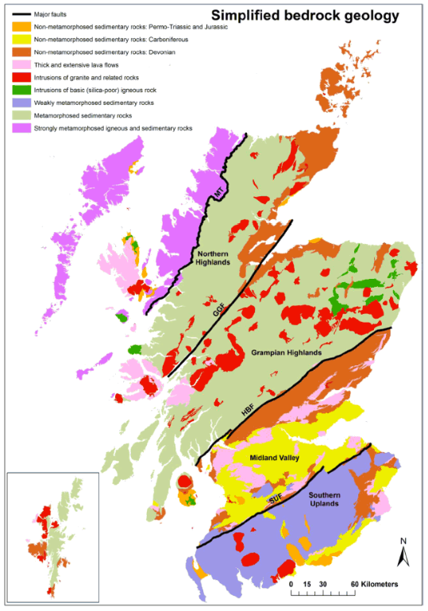

*Simplified Bedrock Geology of Scotland (Gillespie et al., 2013)*

The crystalline basement, found beneath much of Scotland, is formed by weakly to strongly metamorphosed Lower Paleozoic sedimentary rocks. Highly metamorphosed rocks (i.e. gneiss) seen in the Northwest Highlands are likely to be similar to rocks found in the deepest part of Scotland. They originally corresponded to intrusions of granitic and basaltic rocks. In the Northern Highlands and Grampian Highlands, the basement is mainly characterized by a thick sequence of metamorphosed sediments (originally interbedded sandstone and mudstone units). Weakly metamorphosed sediments (sandstone and shale) disrupted by folding, faulting and tilting can be found in the Southern Uplands. Those are intersected by intrusions of basic ingenious rock, generally in the form of laccoliths, as well as granite and other related rocks intrusions. The Midland Valley has only a few small granite intrusions at outcrop but contains numerous minor intrusions, mainly of basaltic and andesitic composition. The metamorphic basement only outcrop along the main faults together with the Devonian Old Red Sandstone sedimentary rocks.

According to geophysical data, the basement-cover boundary is situated at about 8 km depth in the central part of the Midland Valley, against about 15 km depth below the Highlands and Southern Uplands blocks. The basement beneath the MVS and highlands is about 20-25 km thick, with the base of the crust being situated at ~33 km depth, and shows different seismic characteristic to the basement beneath the Southern Uplands. However, some SE extension of the Midland Valley basement rocks have been suggested as a result of similar xenolith assemblages found in intrusions on both sides of the Southern Upland Fault.

### Basin stratigraphy

The MVS mainly consists of a thick sequence of non-metamorphized sedimentary rocks deposited in basin environments during the Devonian-Carboniferous period. Those accumulated as 10 m thick cycles (with maximum of ~30 m), resulting in repeated layers of sandstones, siltstones and mudstones with beds of limestone, coal, fireclay, ironstone and oil-shale (Cameron and Stephenson, 1985). They are intersected by lava flows (mainly of basaltic and andesitic composition) and by pyroclastic rocks up to several kilometers in thickness.

Carboniferous sedimentary succession in the MVS (Browne et al., 1999) is subdivided into four main groups: the Inverclyde, Strathclyde, Clackmannan and Coal Measures groups (Browne et al., 1999).

The Strathclyde Group is separated into ten lithostratigraphic formations that reflect intensive changes in facies during the early-middle Mississippian times. In Fife and East Lothian, the sedimentary rocks form a significant south-westerly prograding, easterly thickening, sandy clastic, fluvial-deltaic wedge (Greensmith, 1962, 1965; Browne and Monro, 1989). Coeval sedimentation in West Lothian and Edinburgh areas is however dominated by lacustrine oil-shales (i.e. “Lake Cadell’’, Cadell, 1925; Greensmith, 1962, 1965).

The Middle Mississippian-Lower Pennsylvanian Clackmannan Group comprises the Lower Limestone (LLGS), Limestone Coal (LSC), Upper Limestone (ULGS) and the Passage (PGP) formations. Whilst the Lower and Upper Limestone formations represent more marine successions, the Limestone Coal Formation represents a return to non-marine/paralic conditions from which significant quantities of coal have been extracted. The Passage Formation marks the upward transition into coal-bearing strata of the Scottish Coal Measures Group.

The Coal Measures Group represents the youngest observable set of sedimentary rocks in the eastern part of the basin. They are subdivided into the Lower (LCMS), Middle (MCMS) and Upper Coal Measures formations (UCMS).

Coal and oil-shale bearing deposits

Most of the coal-bearing rocks located in the Midland Valley in Scotland are contained within the Carboniferous sediments. The thickness of coal seams typically ranges between 1 m (more common) and 3 m (in areas of greater deposition), depending on the thickness of the sedimentary cycle, with some exceptional seams reaching 15 m (Rippon, 2002). The formations of interest are:

The Scottish Coal Measures Group, consists of coal-bearing fluvio-deltaic sedimentary rocks deposited in cyclical sequences of mudstone, siltstone, seatearth, sandstone and coal, in a costal deltaic plain with frequent occurrence of coal swamp conditions. The Group is divided into three formations, based on lithological variations, marine biostratigraphy and non-marine macrofossil assemblages:

* Scottish Upper Coal Measures Formation (UCMS): >1200 m, contains little usable coal.
* **Scottish Middle Coal Measures Formation** (MCMS): 350 m, contains seatrock and coal.
* **Scottish Lower Coal Measures Formation** (LCMS): 240 m, contains seatrock and coal.

Coal Measures Group strata are preserved in the centre of the synclines and basins, in a Carboniferous succession over 2 km thick in the Central Coalfield.

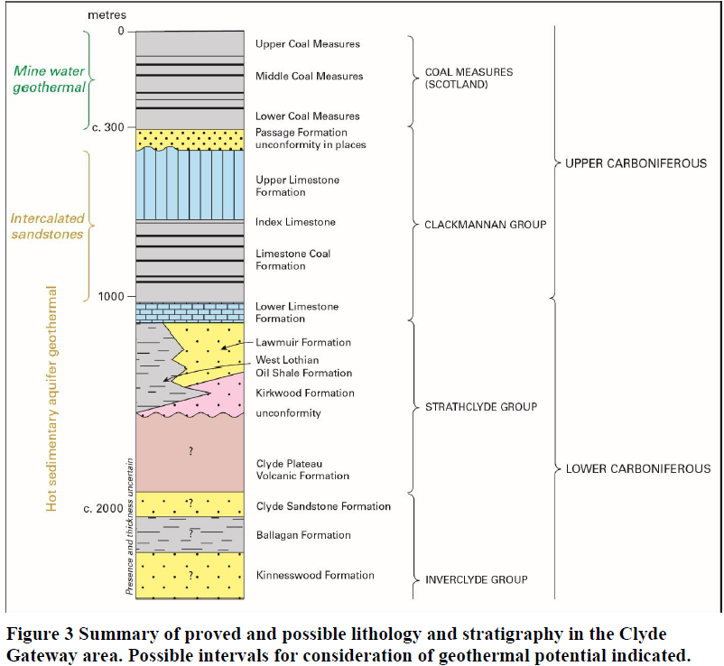

The **Passage formation** (PGP) is dominated by sandstone, some coarse-grained, with red-purple-green-yellow mudstone, seatclay and fireclay, deposited in a dominantly fluvial system with many minor unconformities (Hall et al., 1998).

The Clackmannan Group is divided in three main groups:

* The Upper Limestone Formation (Namurian) is characterized by cyclical sequences of limestone, mudstone, sandstone, siltstone, seatrock and coal (>600 m). Depositional environments are interpreted as ranging from shallow seas, to deltaic and alluvial plains and river channels (Hall et al., 1998).
* The **Limestone Coal Formation (LSC, Namurian)** comprises cycles of coal, mudstone, siltstone, sandstone, seatearth and coal with some thicker mudstone intervals, ironstone and limestone (>550m). CH4 released from coal seams have been measured in the western part of the Central Coalfield (e.g. Bedlay and Cardowan colleries).
* The Lower Limestone Formation (LLGS) is dominated by repeated upward-coarsening cycles of limestone, bedded mudstone, siltstone and sandstone with minor seatrock and thin coal and ironstone (240 m thick), deposited in a quiet marine and non-marine backwater with sandy lobes extending from the east (Hall et al., 1998).

The Strathclyde Group (Visean) comprises sandstone, mudstone, thin coal, seatearth and conglomerate of the Lawmuir Formation (LWM) and the underlying volcanic detritus of the Kirkwood Formation (KRW; Hall et al., 1998), interpreted as having been deposited in fluvial and other environments with a series of marine incursions.

### Structure and Basin history

In the Midland Valley of Scotland, both normal faults and high angle reversed faults can be found (Browne et al., 1985), suggesting a complex succession of deformation phases. Fault dips vary from near-vertical to 50° with evidence of normal (e.g. East Ochil), reversed (e.g. Pentland) and strike-slip (e.g. Crossgatehall, Adross Fault) movements. The E-W trending West and East Ochil faults, the NW-trending Dechmont Fault and the NE-trending Pentland Fault, with throws of up to 1.8 km, represent the main basin bounding structures. Faults with smaller throws of up to ~800 m (e.g. the E-W to NE-SW striking Wilsontown, Campsie faults) bound parts of the basin while faults with throws ranging from ~ 200 to 400 m (e.g. Comedie, Bothwell, Crossgatehall faults) only offset the basin fill succession.

The MVS is moreover composed of a series of inter-related depo-centers and intra-basinal highs that results from a complex basin evolution during the Carboniferous, which has been subjected to many controversies (Underhill et al., 2008). This basin history has been summarized in four main stages:

* Late Devonian to Early Carboniferous basin formation in the Variscan foreland, following the closure of the Iapetus Ocean (Silurien times 440-425 Ma)
* Mid to Late Carboniferous basin formation to inversion
* Latest Carboniferous to Permian tholeiitic magmatism and post-orogenic extension
* Post Carboniferous deposition, burial, rock lithification, uplift/folding and erosion (~300 Myr)

Major NNE-SSW striking folds can be seen in the eastern part of the MVS. It comprises the Clakmannan, the Midlothian and the Leven Synclines (which contain significant coalfields, i.e. the Midlothian Coalfield, Tulloch and Walton, 1958) separated by anticlines (i.e. Balmule, Burntisland and D’Arcy-Cousland Anticlines). The Clackmannan Syncline, interpreted as a Visean syn-sedimentary syncline (Hooper, 2004), is the largest structure in the Midland Valley, and is best-defined at its northern ‘Kincardine Basin’ end. It is cross-cut by the E-W striking narrow ‘Forth Graben’, a syn-depositionally active extension of the Kilsyth Basin, bounded in the north by the Banknock Fault. The Midlothian-Leven Syncline is also suggested to have been forming by syn-sedimentary growth within a dextral strike-slip regime during from the Late Visean-Westphalian (Early Carboniferous), followed by a Late Carboniferous fold tightening and reverse faulting affecting rocks from the Coal Measures Group (Underhill et al., 2008). The truncation of some faults buried by sediments and volcanic rocks suggest that some faults became inactive after the early Carboniferous. The Lanarkshire Basin, situated in the Central Coalfield area, represent a deep low in the Midland Valley, separated from the Clackmann Syncline by the Salsburgh Anticline. In this area, Visean fault growth has also been suggested from seismic interpretation (Hooper, 2004). Syn-depositional growth on ENE-trending fault structures (i.e. Bothwell Fault) was indeed recorded in the Lanarkshire Basin in the hanging wall of the Dechmont Fault (Hooper 2004), even though much of the large throw on the Dechmont Fault is considered post-depositional (Paterson et al., 1998). This was followed by Basin subsidence during the Namurian and by a subsequent post-depositional inversion that formed the current anticlinal structure.

The truncation of the Late Carboniferous structures by E-W striking Latest Carboniferous-Early Permian normal faults, quartz-dolerite dyke swarms and extensional fractures, indicate that their formation was complete by the end of the Carboniferous (Rippon et al., 1996; Stephenson et al., 2003; Monaghan and Parrish, 2006). Together with the lack of evidence for continued subsidence in the synformal depocenters, it suggests that dextral strike-slip had been replaced by N–S tension by latest Carboniferous-Permian times (Glennie and Underhill, 1998). It has been proposed that the West Ochil, buried during the Namurian-Westphalian, was reactivated during the late Carboniferous N-S extension (Rippon et al. 1996). Similarly, the Pentland fault could have been reactivated during Early Neogene (Cenozoic) uplift (Anderson,1951).

During the Paleogene, the area was indeed affected by an increasing amount of regional uplift towards the west. Most of the sedimentary rocks of the Middle or Upper Pennsylvanian (Late Carboniferous) in the eastern MVS basin are presumed to have been eroded during either Late Carboniferous (Variscan) deformation or Paleogene uplift events. Thermal modeling around the Midlothian–Leven Syncline indicated a burial of Carboniferous strata up to 2 km prior the Cenozoic uplift (Vincent and Rowley,2004), suggesting that most of post-Carboniferous sediment rocks (> 1.3 km of sedimentary cover) have been removed in this area.

Taking together the various orientations and ages of fault and fold structures Hooper (2004) favored a Visean-Westphalian dextral transtension model for the Central Coalfield, cut by later E-W faults. The presence of intra-basinal N-S striking structures indeed suggests that basin results from an E-W extension accommodated by extensional faults with listric geometries and steeply dipping transfer faults (Stedman, 1988; Haszeldine, 1988; Gibbs, 1990)., Read (1989) particularly highlighted the role of dextral strike-slip during Upper Carboniferous in the variety of fault and fold structures located in the footwall of the East Ochil and Campsie Faults.

### Magmatism

Magmatic activity in the MVS lasted for ~90 Ma (Upton et al. 2004), extending from the Carboniferous to Permian. Early magmatic activity in the MVS occurred in the Pentland Hills (Lower Devonien, >400 Myr) in the form of lava flows and ash layers (basalt, andesite, trachyte and rhyolite) that are part of a large volcanic field. The Pentland Hills constitutes an intra-basin high in the MVS originally formed of Silurian sediments deposited 430-440 Myr ago (today highly metamorphosed and folded) in the closing Iapetus Ocean (see reversed Pentland Faults). Erosion since the end of the Ice age gave the Pentland Hills its current shape.

Early Carboniferous activity (Visean ~330-340 Myr) comprised basaltic to rhyolitic lavas, tuffs and related intrusions formed from short-lived volcanoes (e.g. Garleton Hills, Arthur’s Seat, Clyde Plateau Volcanic Fm). Those eruptions occurred in flood plain environment, resulting in the formation of explosive materials (ash, blocks). Later Visean and Namurian (~313-326 Myr) activity (e.g. Kinghorn and Bathgate Hills volcanic Fms) was dominated by basaltic lavas and tuffs (Smedley 1986, Stephenson et al. 2003, Upton et al., 2004).

In the late Carboniferous, short-lived extensional interval of tholeiitic magmatism extended across the MVS (Timmerman 2004, Monaghan & Parrish 2006), mostly occurring in the form of dolerite intrusive sills (e.g. Salisbury Crags) between sedimentary layers. Mantle xenoliths found in the Late Carboniferous layers have moreover been interpreted as evidences for a dextral strike-slip regime in the MVS during that period, as xenoliths originate from deep-seated sub-vertical fault zones able to transect the crust to tap a mantle source (Macintyre et al., 1981; Upton et al., 1983; Aspen et al., 1990). During the Permian, alkaline magmatism (Wallis 1989) related to post-orogenic extension was finally recognized across NW Europe, including in Scotland (Neumann et al. 2004).

Magmatism in the MVS influenced the basin structure in different ways. First, the large volume of magmatic material impact strongly the basin palaeogeography, forming locally significant proportion of the basin fill succession. During the Carboniferous, magmatism resulted in an increased heat flow in the western part of the Midland Valley, more volcanically active. Intrusive magmatism in the late Carboniferous finally locally enhanced sediment maturity up to ranks of Ro=6% within an approximately 300 m aureole of higher rank in the Sill Complex area.

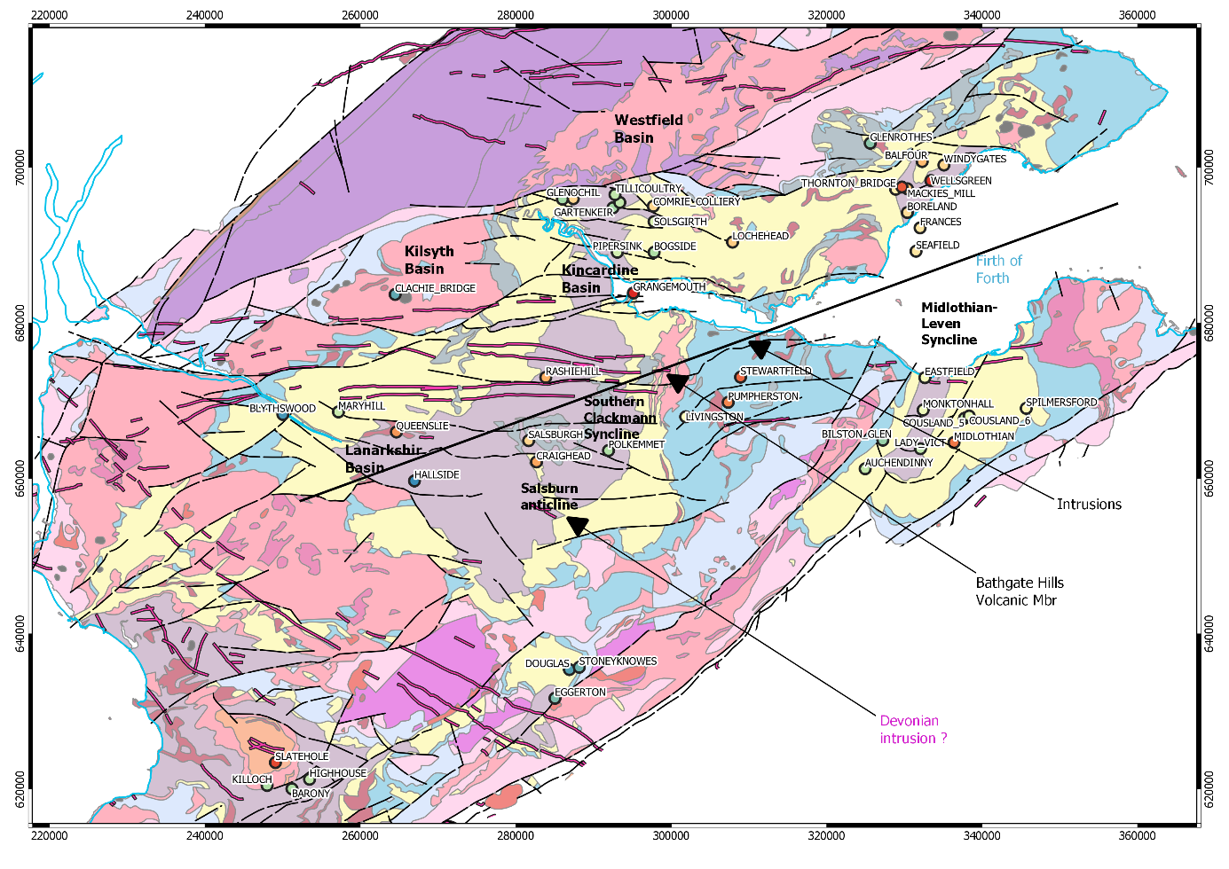

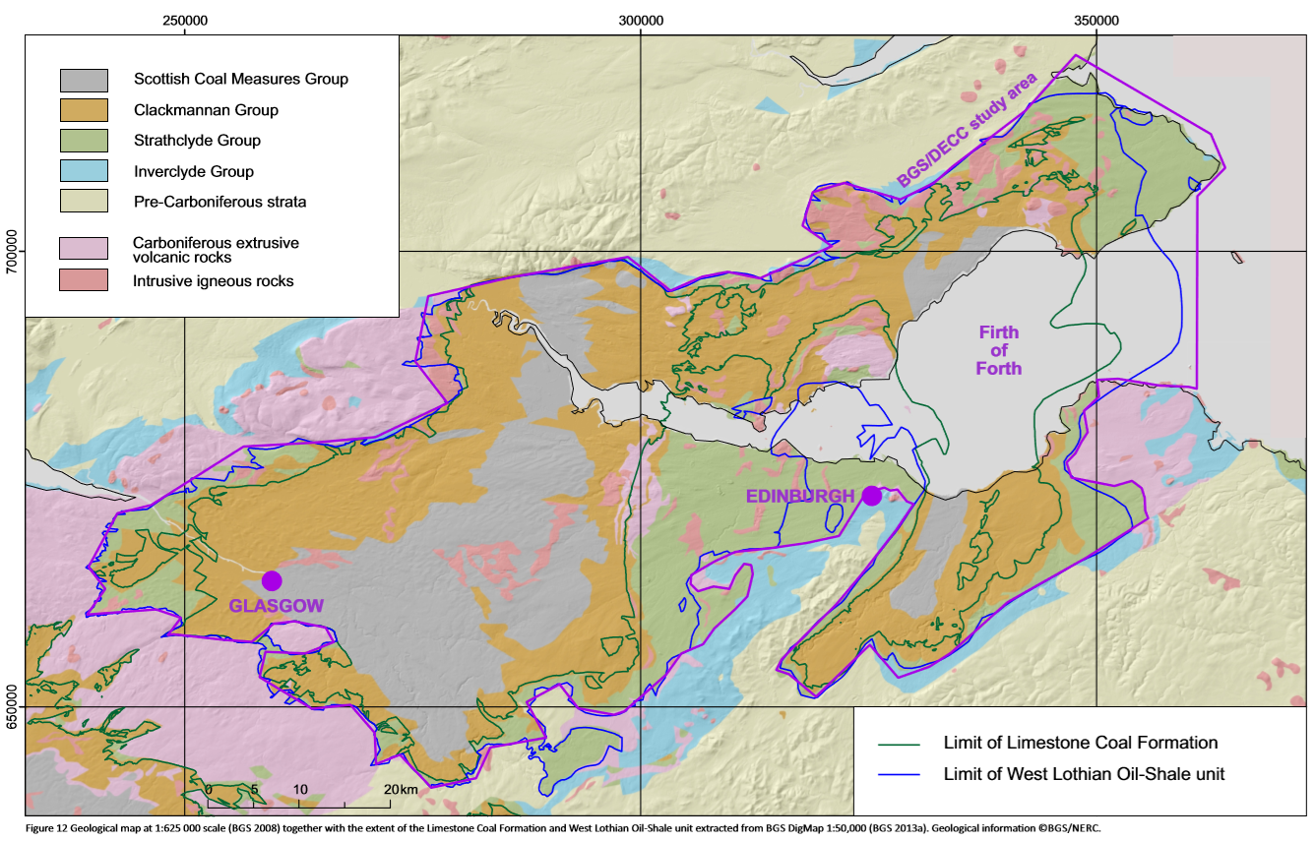

*Figure 9. Geological map at 1:625 000 scale (BGS 2008) together with the extent of the Limestone Coal Formation and West Lothian Oil-Shale unit extracted from BGS DigMap 1:50,000 (BGS 2013a). Geological information ©BGS/NERC (Monaghan, 2014).*

### Geophysical Data

The magnetic anomaly map shows high anomaly in the area of the Bathgate Hills Volcanic Formation, south from the Central Coalfield. This has been interpreted as the result of a large basic igneous mass extending to a depth of 5 km or more beneath overlying lavas, potentially separated from the basement by Devonian sedimentary and volcanic rocks (Rollin et al. 2009). Other volcanic centres (e.g. Campsie, Garleton and Burntisland) were also modelled as a lava pile over a deep intrusive source.

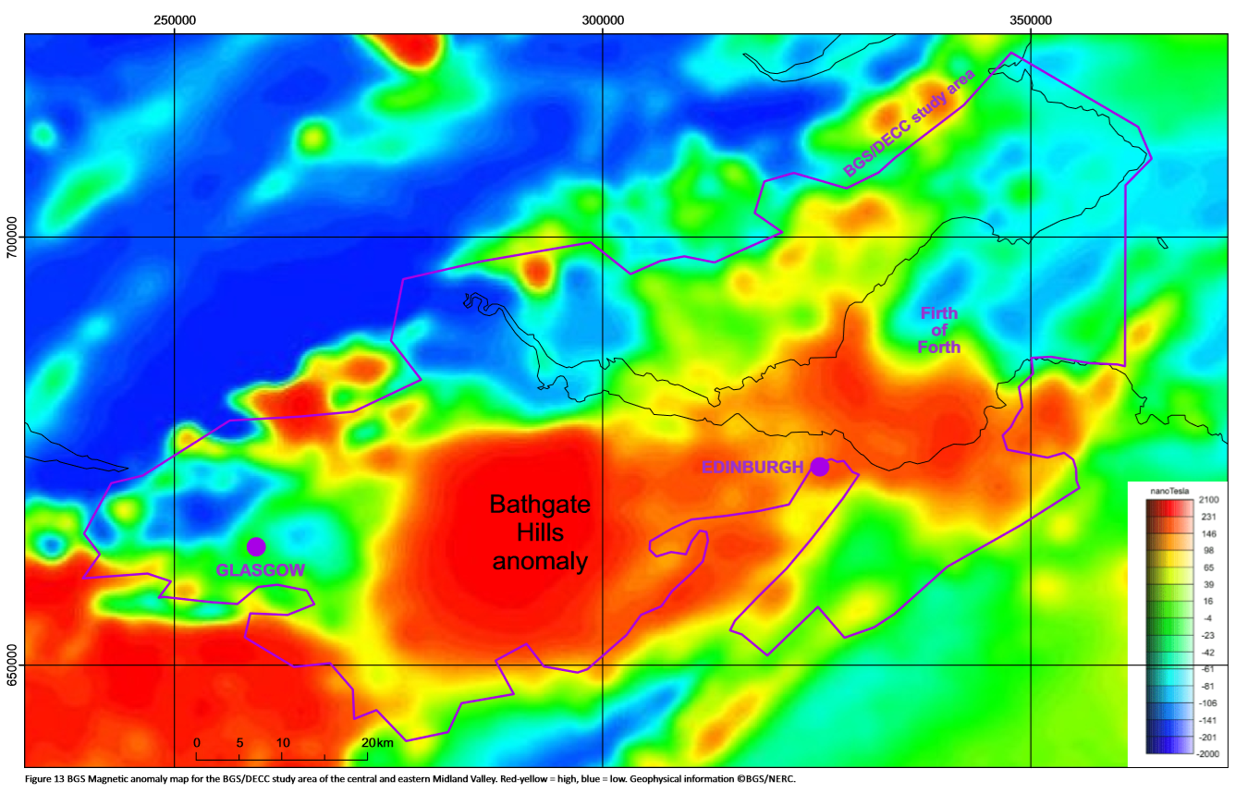

*Figure 7. BGS Magnetic anomaly map for the BGS/DECC study area of the central and eastern Midland Valley. Red-yellow = high, blue = low. Geophysical information ©BGS/NERC (Monaghan, 2014).*

Gravity anomalies suggest that an east-west basement horst extends from the Bathgate area to the Garleton Hills (East Lothian; Rollin et al. 2009). Both the Highland Boundary and Southern Upland faults can be observed in gravity and magnetic data, along with the position of the East and West Ochil Fault.

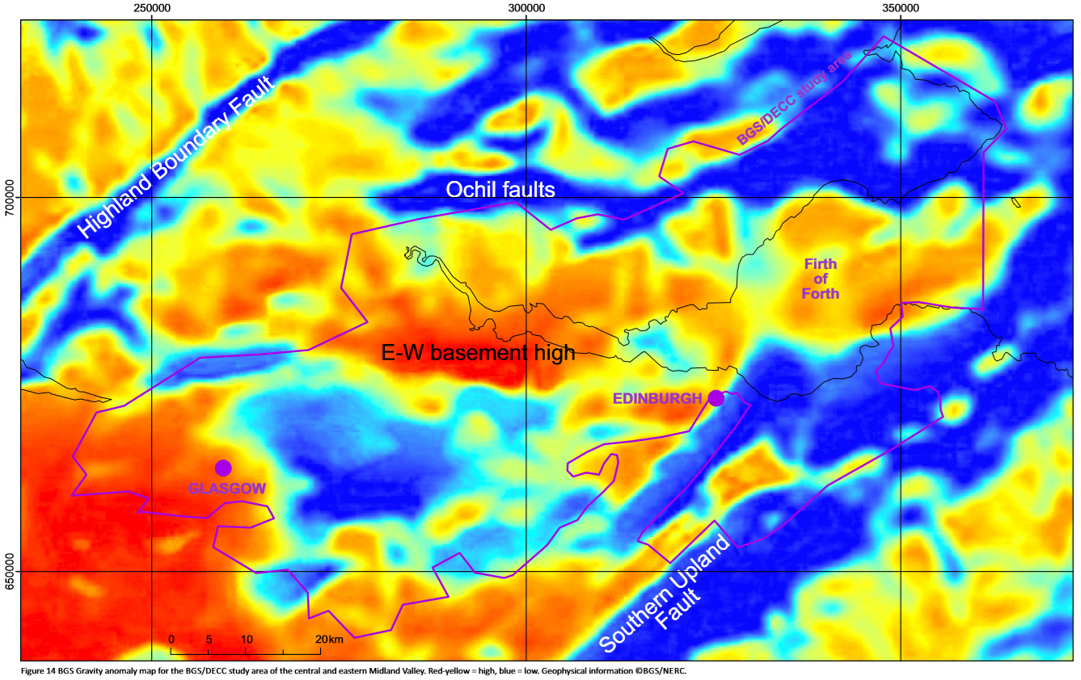

*Figure 8. BGS Gravity anomaly map for the BGS/DECC study area of the central and eastern Midland Valley. Red-yellow = high, blue = low. Geophysical information ©BGS/NERC (Monaghan, 2014).*

## Aquifer systems

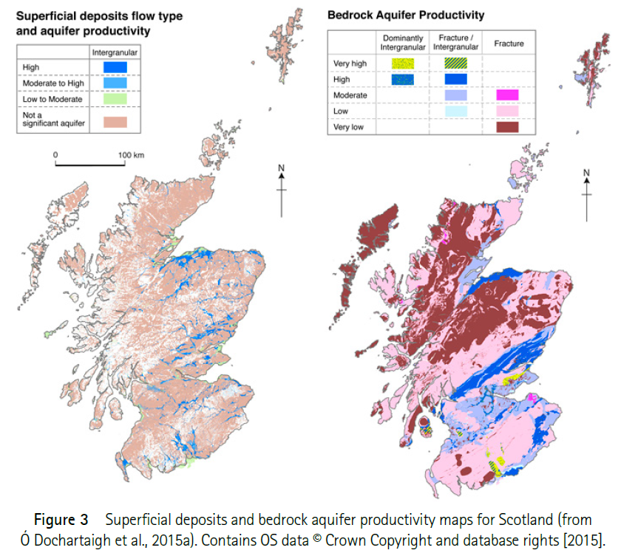

*Superficial deposits and bedrock aquifer productivity maps for Scotland (Dochartaigh et al., 2015).*

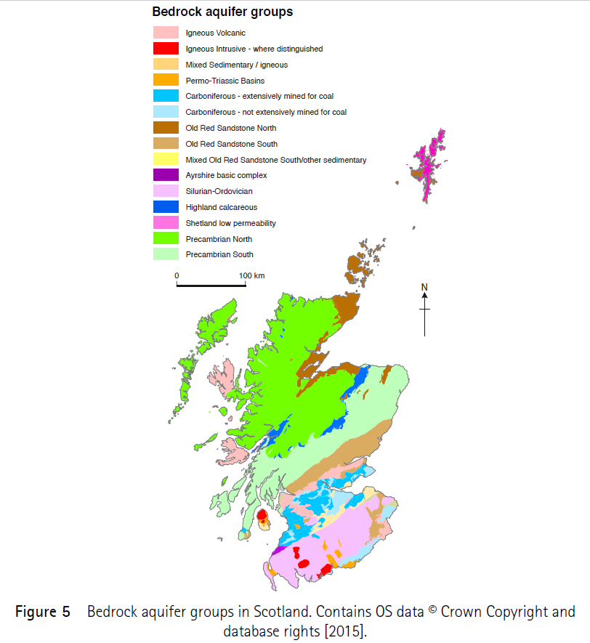

*Bedrock aquifer groups in Scotland. Contains OS data © Crown Copyright and database rights (2015)*

|  |  |  |  |  |  |  |  |  |  |  |  |
| --- | --- | --- | --- | --- | --- | --- | --- | --- | --- | --- | --- |
| Aquifer | Dominant flow type | Aquifer productivity | Path length | Flow depth | Chemical type | Overlying strata | Porosity (%) | K (m/d) | T (m²/d) | Cp (m3/d.m) | Operational Yield (m3/d) |
| Carboniferous not extensively mined for coal | Fracture  Intergranular (Passage Fm) | Moderate -High (Passage Fm) | 100 m | Years to millennia | Anoxic, moderately mineralised | Thick and low permeability | 12-17 | 3e-4 – 0.1 | 10 – 1000 | 48 -132 (min: 0.43; max:1320) | 131 -418 |
| Carboniferous extensively mined for coal | Fracture  Through mine voids | Moderate | 1 – 10 km | Month to millenia | Often anoxic, moderate to highly mineralised (high Fe) | Low permeability, thick in valleys | / | / | 10-1000 | 48 -132 (min: 0.43; max:1320) | 1987-3279 (min 41 ; max 22 2248) |

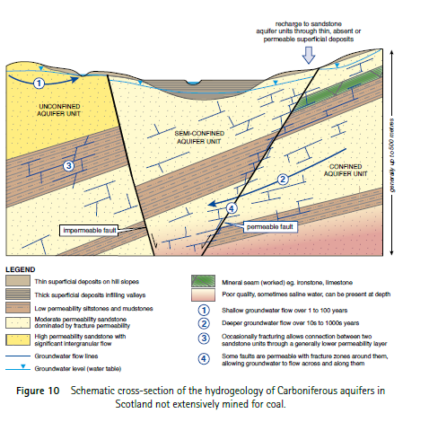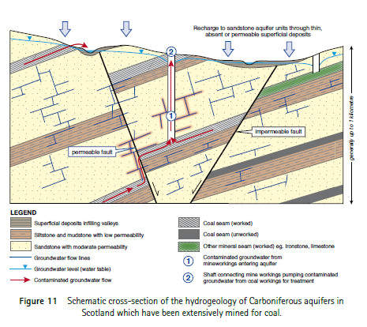

### Carboniferous sedimentary aquifers not extensively mined for coal

These Carboniferous sediments are part of the Strathclyde, Inverclyde, Border and Yoredale geological groups. They consist of repetitive sequences of sandstone and siltstone beds with thinner interbedded mudstones and limestones of various permeability, with little or no coal and some oil shales. The thickness of the sequences varies from 600 to 1000 m in Southern Scotland and up to 2 – 3 km in the Midland Valley (Read et al., 2002). The Carboniferous sedimentary rocks typically form multilayered and vertically segmented aqui­fers. The fine grained and well cemented sandstones tend to form moderately productive aquifers with relatively low intergranular porosity and permeability and fracture dominated flow, separated by lower permeability siltstones, mudstones and coals. The sedimentary sequences are divided vertically by faults that act as permeable pathways or barriers to groundwater flow. In contrasts, the Passage Formation forms an exten­sive productive aquifer where groundwater moves by intergranular flow (Ball, 1999). The natural layering of the Carboniferous aquifers is likely to create complex flow path, dominated by horizontal and fracture flow. Some higher transmissivity and specific capacity values might moreover indicate the presence of areas impacted by mining. Both unconfined and confined aquifers are likely to be found in various aquifer layers, in which the groundwater residence time has been estimated to be in excess of 60 years (Ó Dochartaigh et al., 2011).

### Carboniferous sedimentary aquifers extensively mined for coal

The Scottish Coal Measures Group and parts of the Clackmannan Group (excluding the Passage Formation) represent the geological formation the most extensively used for coal extraction. Those carboniferous sedimentary strata in the MVS are generally described as moderately productive aquifers due to a relatively low rock permeability, providing borehole yields in the range 5-15 l/s (MacDonald et al., 2004; Robins, 1990; Ball, 1999). Unmined coal-bearing strata characteristics are similar to those of the aquifers not extensively mined for coal. They tend to form complex multi-layered minor aquifers, with vertical and lateral variations of low permeability layers (mudstone) interbedded with higher permeability layers (sandstone, limestone), also compartmentalized by intrusions of igneous rock (dykes, sills, plugs) and faults. Despite the presence of coal seams is adding more low-permeability layers between the sandstone aquifer units, they generally have slightly higher productivity than the aquifers not extensively mined for coal.

Mining activities resulted in an increase in permeability of the strata both by increasing the void space in zones where seams were mined out and through fracturing of competent horizons above the mined seams (i.e. subsidence-related stressing), creating “anthropogenically enhanced aquifers” (Banks, 1997). In addition, remnant shafts and tunnels provide large diameter artificial flow pathways, increasing the aquifer transmissivity across large areas and depths by linking both laterally and vertically formerly separated groundwater flow systems. While mining voids can locally increase aquifer storage, collapse of roofs above large voids and deformation of the surrounding rock mass can modify both transmissivity and storage (Youner and Robins, 2002). Mining therefore tends to add more complexity to the groundwater flow paths.

In those formations, aquifers can be found both in confined or unconfined conditions, and with different head in different aquifer layers and/or mining levels. Only a few aquifer properties data from pumping test are available for boreholes intercepting former mines. The creation of voids and fractures by mining activities moreover contribute to the formation of large rock-water surfaces within flooded abandoned workings, providing an increased potential for heat exchange (Banks et al., 2003; PB Power, 2004).

|  |  |  |
| --- | --- | --- |
| Formation | Colliery | Flow rate |
| Limestone Coal Formation | Prestongrange Colliery [NT 373 737] | 40-75 l/s over 140 h/week at 165-225 m depth |
| Kilsyth Colliery [715 779] | 150 l/s at 206 m depth |
| Twechar Colliery [701 762] | 13 l/s for 12h/day ay 317m |
| Monktonhall Colliery, Midlothian | 35 l/s |
| Blindwells Colliery, East Lothian |  |
| Scottish Middle Coal Measures Formation | Bothwell Colliery [686 588 | 230 l/s at 396 m depth |
| Scottish Lower Coal Measures Formation | Polkemmet Colliery, West Lothian | 75 l/s |
| Frances Colliery, Fife | 120 l/s |
| Limestone Coal formation and/or Coal Measures | Falkirk District | 30-55 l/s |
| Blindwells Colliery, East Lothian | 315 l/s |

*Historical mine dewatering rates (Gillespie et al., 2013)*

### Groundwater chemistry

The groundwater chemistry of the Carboniferous sedimentary aquifers in the Midland Valley has been described by Dochartaigh et al. (2011) and is summarized in the table below.

|  |  |  |  |  |
| --- | --- | --- | --- | --- |
| Group | Coal Measures | Clackmannan | *Inverclyde* | *Strathclyde* |
| Type | Bicarbonate | Ca-Mg-HCO3 | Ca-HCO3 | Ca-Mg-HCO3 |
| Na | Dominant (or none) | Dominant for some samples | Low | Dominant or no anionic dominance  Moderate |
| Ba |  | Moderate to high |  |  |
| Mg | Moderate | Moderate | Moderate |
| Cl | Low |
| SO4 | Highest average, except mine waters | Low |
| Ca | Moderate: Calcite close to saturation | Moderate to high: undersaturated calcite | Moderate: Calcite close to saturation | Moderate: Calcite close to saturation or undersaturated (50%) |
| Fe | Highest average, except mine waters | moderate to high (variability due to redox conditions in the aquifer) | Low | Low average |
| Mn | Moderate |
| HCO3 |  | High | Moderate | Moderate |
| Alkalinity | Highest, including for mine waters |  |  |  |
| SEC | Highest average, except mine waters | Moderate average | Moderate average | Moderate to high |
| Conditions | Anoxic | Low dissolved O2 | Low dissolved O2 but not anoxic (oxic) | Not anoxic |
| pH | Slightly acidotic to near-neutral | near-neutral | Near-neutral | Near-neutral |

## Geothermal data

Scotland is located on a geologically stable part of Earth’s crust, with no apparent substantial heat resource in accessible parts of the subsurface (Gillespie et al., 2013). Gillespie et al. (2013) calculated the average temperature gradient for boreholes in Scotland from the surface temperature, the bottom-hole temperature (BTH) and the depth of the measurement, using data from Burley et al. (1984). The average temperature gradient for 61 shallow onshore boreholes ranges from 3.7 to 45 °C/km, with a mean of 22.5 °C/km and a median is 21.5 °C /km. Plotted together, the data indicate an average gradient of 30.5°C/km which correlates throughout the entire depth range intersected by those boreholes (<1.5km). Using 133 BTH from 72 offshore wells in the North West Margin area (Gatliff et al., 1996), average temperature gradients for depth ranges of 1.5-3.5 km and > 3.5 km is of 36°C/km and 47°C/km, respectively.

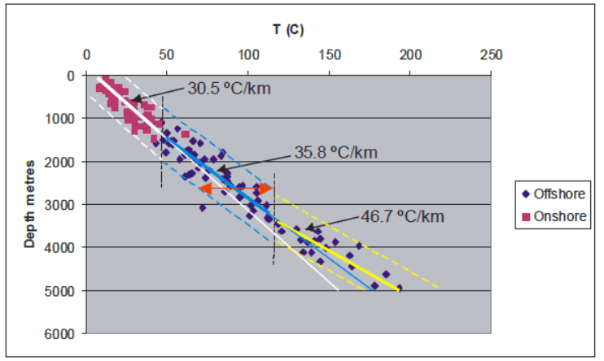

*Combined onshore and offshore BHT (Gillespie et al., 2013)*

In addition heat flow in Scotland was calculated from 35 published heat flow values from onshore boreholes < 400 m depth, including 13 in the Midland Valley, collected in BGS Catalogue of Geothermal Data for the UK (Burley et al., 1984). Values ranges between 29 and 82 mW.m-2, with mean and median of 56 mW/m2 and 57 mW/m2, respectively. Apparent ‘hot spots' corresponding to granite intrusions were identified in the central part of the Midland Valley and in the East Grampians region, with heat flows of 60 mW/m2 and 70 mW/m2, respectively.

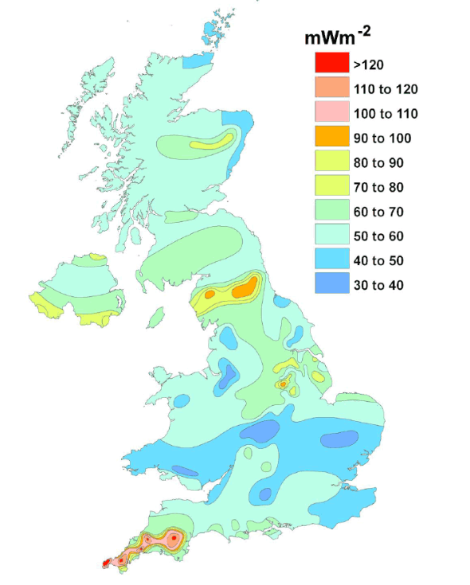

*Heat Flow in the UK (Gillespie et al., 2013)*

The gradient for onshore data is defined mainly by boreholes in the Midland Valley. However, sedimentary basins such as the MVS commonly results from the stretching of the crust that might be thinner and thus display a higher heat flow relative to adjacent areas underlain by thicker crust. Only a few temperature data were acquired form crystalline rocks in onshore parts of Scotland (and none from > 300 m depth). However, 16 of the wells forming the North West Margin dataset terminated in the crystalline basement rocks that underlie the sedimentary cover, and thus, the bottom-hole temperatures (BHT) in these wells represent temperature data for crystalline rocks. The T-z trends shown below suggests that similar temperature is not dependent on the type of rock (crystalline basement or in sedimentary cover rocks).

The geothermal gradient has been defined by data from boreholes and wells that penetrate a range of rock types (crystalline and non-crystalline) and structural regimes (basin and ridge settings) both onshore and offshore, and is essentially continuous throughout the zone in which the deepest onshore data and shallowest offshore data overlap. This suggests the regional temperature gradient may be broadly the same in both settings (onshore and offshore). Moreover, the temperature range defined by the data at all depth is never greater than 46ºC. The limited scatter of the data, together with the broad geographical extent of the measurements and the continuity of the trend throughout the full 5 km depth, suggests that a consistent regional geothermal gradient exists beneath much of Scotland and remains unperturbed across the basement-cover interface. Thus, the temperature at any given depth down to 5 km could be predicted with a precision of approximately ±23 ºC.

Compaction of sedimentary rocks is likely to increase their thermal conductivity. This means that the geothermal gradient in sedimentary rocks should decrease with increasing depth if the heat flow profile is consistent. Several factors might also affect the surface temperature and thus a good estimation of the geothermal gradient, such as the presence of local source of heat (i.e. granite intrusions), the topography, recent climate change, the presence of low conductivity “cap” rock above a heat source leading to “trapped heat”, heat refraction due to inclined strata, or convective heat transfer. Thinner crust in offshore areas may account for a higher geothermal gradient in the deepest part of the curve.

When extrapolated to the surface, the best-fit geothermal gradient for shallow temperature gradient indicates a surface temperature of 4.0°C, which is lower than the current annual average surface temperature in Scotland of about 10°C. This indicates that the shallow part of the geothermal gradient measured in shallow boreholes (< 400m depth) must steepen and thus, the rate of increase in temperature with depth will appear to be smaller (Gillespie et al., 2013). This supports the hypothesis that Holocene warming had an impact on near-surface temperatures in Scotland (Westaway and Younger, 2013 and Busby et al., 2015).

Climate warming since the last glaciation may indeed account for a lower geothermal gradient near the surface. Studies in the Canadian sedimentary basin showed that heat flows were generally underestimated by 10-18% for wells shallower than 1 km due to the paleo-climatic effect (Majorowicz et al., 2012). The significant change in surface temperature since the end of the ice age, where temperatures where much cooler than at present, indeed caused perturbations of the near surface heat flow by propagating a warming pulse down to 2 km depth, expressed by a greater temperature gradient in the basement. The post-glacial warming signal has been estimated in the order of 10-15 °C (Gosnold et al., (2011). Individual temperature measurements from shallow boreholes therefore tend to underestimate the geothermal gradient and thus the size of the heat resource at depth (e.g. Westaway and Younger, 2013; Busby et al., 2015). This shows the importance of taking into consideration paleoclimatic corrections to heat flow data, using a sufficient number deep temperature profiles in equilibrium.

### Hot sedimentary aquifers (HSA)

The geothermal potential of Devonian-carboniferous sandstone aquifers in the MVS has been investigated in the 80’ (Brown et al., 1987). Investigations highlighted the complexity of the geological structure of the MVS linked to the depositional environment (i.e. difficulty to extrapolate between boreholes due to diverse lithologies, presence of fault/intrusions, complex groundwater flow resulting from coal mines). While Permian and Triassic rocks are likely to represent the most productive aquifers, most of the Carboniferous sandstone aquifers, excepting the Passage Formation, are contained with relatively thin strata with a low natural permeability and a restrictive geographical distribution.

The main HSA prospect, the ~170 m thick Knox Pulpit Sandstone Formation (Upper Devonian Stratheden Group), composed of weakly cemented wind-deposited sandstones, can be found at 4 km depth in the MVS (Gillepsie et al., 2013). Low permeability and low thermal conductivity volcanic rocks (basaltic and andesitic lavas and pyroclastic deposits) overlying sedimentary rocks in the MVS have been suggested to represent “cap rocks” to HSA systems, by trapping both heat and water in underlying sedimentary aquifers. Those include:

* Devonian basaltic and andesitic rocks under the Ochil Hills and Sidlaw Hills in the NE MVS and under the Carrick Hills and Pentland Hills in the SE MVS
* Carboniferous basaltic rock beneath Renfrewshire, Kilpatrick, Campsie and Gargunnock hills in the west and under the Garleton Hills in the east.

New and more detailed heat flow measurements (through the drilling of new inclined wells in those areas) would be necessary to identify potential thermal anomalies beneath igneous rocks. In addition, testing deep boreholes could be used to infer the actual permeability (and its change with depth) together with the overall productivity at depth to determine HSA potential.

### Hot Dry Rocks and HHP Granite

The regional “background” geothermal gradient calculated for Scotland in Gillepsie et al. (2013) suggests that a temperature of 150C would be reached at 4-5 km depth. However, this is limited by the lack of onshore temperature measured in crystalline rocks at a depth higher than 2 km. For HDR systems, it is of interest to identify local thermal anomalies at accessible depth (i.e. additional heat generated in situ, trapped heat).

High Heat Production (HHP) granite intrusions (with an estimated minimum capacity of 4.0 μW m-3) are likely to be the only source of additional in-situ heat generated beneath Scotland, while only low-conductivity rocks are likely create situations where the vertical upflow of heat is trapped at depth.

The largest and greatest concentration of intrusions is located in the block of crystalline rocks bounded by the Highland Boundary Fault and the Great Glen Fault. Only granite (sensus stricto) intrusions contains sufficient concentration of K,T and U element to generate heat by radioactive decay that would have a geothermal significance. Those granite intrusions occured during different events:

* < 10% occured during crustal stretching that preceded/accompanied the opening of the Iapetus Ocean, ~600 million years ago. Those intrusions can be found in the Grampian Highlands and Northern Highlands, and are unlikely to have HHP character (small and chemical composition not favorable).
* Most of granitic intrusions were formed in association with the Caledonian Orogeny (closure of the Iapetus Ocean) between 500-400 Ma ago
  + the Grampian Event (c. 490–460 Ma) produced large bodies of granite/ granodiorite south of Inverness and near Aberdeen, with low HP values (0.6–2.2 μW/m3).
  + The Scandian Event (c. 435–420 Ma) produced numerous intrusions of granite, granodiorite and diorite, mostly in the Grampian Highlands region. HP values for granite *sensus stricto* ranges from 2.2 to 7.3 μW m-3, with the mean HP values for 8 of them (the Helmsdale, Fearn, Abriachan, Bennachie, Mt Battock, Ballater, Cairngorm and Monadhliath intrusions) being >= the threshold for HHP character (4 μW.m-3)
  + Two large intrusions (Fleet and Criffel), with HP values of 3 and 2.2 μW m-3 were emplaced in Southern Scotland, at the end of the Caledonian Orogeny (410–390 Ma).

“*The Midland Valley represents the largest onshore area in Scotland where a thick pile of sedimentary rocks overlies crystalline basement. The sedimentary strata in places contain numerous seams of coal, which has very low thermal conductivity and so is an excellent thermal insulator. The coal seams are, however, very thin compared to the interbedded mudstones and sandstones that will mainly determine the thermal conductivity profile, and the degree to which they would act as a thermal insulator is not clear. The nature of the basement rocks beneath the Midland Valley is very poorly understood, and the extent to which intrusions of granite (let alone HHP granite) might exist in them is not known, and may be impossible to determine. Only one intrusion of granitic rock of significant size actually crops out within the Midland Valley; the* ***Distinkhorn intrusion*** *consists of diorite and granodiorite, and has low HP capacity (2.0 μW m-3). The potential for locating and exploiting a hot buried granite in the Midland Valley therefore appears to be very small; however, if granite intrusions do exist in the basement rocks, the heat they supply to the overlying sedimentary rocks may contribute to the geothermal energy potential in Hot Sedimentary Aquifer settings and abandoned mine workings*.“ (Gillespie et al., 2013)

Low thermal conductivity rocks such as basaltic and andesitic lavas (with values of ~ 2.2 W/m.K in the Midland Valley) have a potential to embody large heat reservoirs (elevated temperatures compared to other rock types) in order to maintain consistent geothermal gradient. This effect is particularly enhanced if the supply of heat from depth exceeds normal background values (i.e. residual heat from magmatism). The low thermal conductivity of basic (silica-poor) igneous rocks forming large intrusions in Aberdeenshire (e.g. Morvern-Cabrach, Insch and Huntly-Knock intrusions), means they may be hotter than rocks of higher thermal conductivity in the same area. Those intrusions are interpreted to overlie the East Grampians Batholith (part of which consists of HHP granite), with their bases at between 1 and 5 km depth, which might provide a boost to background heat flow in the area.

### Minewater temperature in the UK (see appendix XXX)

Minewater temperatures reported in the BGS Catalogue of Geothermal Data for the UK (Burley et al., 1984) have been analyzed by (Gillespie et al., 2013). Temperatures measured from nine boreholes in the Midland Valley range from 12 to 21°C, with a mean and median of 17 °C. The average temperature for water circulating above 200 m depth has been reported to range between 8 and 15 °C (Robins, 1990). Despite the temperature of mine waters generally increases with depth according to the geothermal gradient, no correlation has been found between the depth of the measurements and the observed water temperature in the Midland Valley. In autumn 2008, new groundwater samples were collected from boreholes abstracting water from Carboniferous sedimentary aquifers across the Midland Valley, as part of the Scotland Baseline Project. Four of them originate from abandoned flooded mine workings (i.e. either pumped or from gravity-driven discharge zones). Temperatures of two of the measured pumped mine-water were 11.7 and 14.5 °C, in accordance with the typical temperature of natural groundwater from Carboniferous aquifers in the Midland Valley. Temperature of the sampled mine-water pumped from the Polkemmet mine shaft was 19.2 °C, while the measured temperature of the gravity-driven discharged mine-water was 9.8°C. Average mine water temperatures of 11.5-13.3 °C and 14-15°C were reported for the Crynant, Dulais Valley, South Wales Coalfield (Farr et al., 2016) and Caphouse Colliery (Burnside et al., 2019), respectively.

Farr et al. (2016) however noted some uncertainties in the temperatures measurements in existing database (i.e. BGS geothermal Catalogue and RECALL database), limiting the reliability of geothermal gradient estimates. This includes the lack of knowledge of the depth and timing of temperature measurement after the drilling of the boreholes, the effect of circulation of water within the borehole and the influence of intercepted mine working.

In their study, Farr et al. (2016) assessed the low enthalpy heat recovery potential from coal mine discharges in the South Wales Coalfield based on water chemistry analysis. Despite relatively constant temperature measured at each of the 16 sites during the monitoring period, temperature differences between each of them were attributed to the position of the logger relative to the surface features. By comparing the mine water temperature to the average monthly air temperature, Farr et al. (2016) showed that measured temperature can be influenced by 1) cold recharge entering the drainage system (i.e. shallow logger in gravity driven adit, correlated with air temperature), 2) localized recharge events such as period of intense rainfall (i.e. adits with transfer pumps with more stable yearly temperature) or 3) the absence of connection with surface recharge (i.e. deep warm water with constant temperature throughout the year). Groundwater of different temperature may indeed enter the borehole at different depths, exchanging heat with the surrounding rocks to a degree that will depend on the flow rate, making it difficult to predict the temperature of the pumped water.

# Mine conceptual models

Mine aquifers are characterized by a triple-porosity composed of the primary rock porosity, the mining voids (i.e. galleries, shafts, roads…) and mining-induced fractures (Wolkersdorfer, 2008). After the closure of the mine, some galleries may be filled or partially field by collapsed roof material and the former shafts backfilled using rubble from demolished topside colliery infrastructure before being capped. Many shafts, roadways or drifts however remain as open and interconnected voids (Younger et al., 2002). These voids tend to form zones of high permeability pathways in the mine, altering the natural groundwater flow within aquifers of initial low hydraulic conductivity. Unmined coal-bearing strata in the coal measures indeed form complex multi-layered minor aquifers, laterally and vertically compartmentalized through the presence of low permeability layers (i.e. mudstone) in between sandstone aquifers, igneous rocks (dykes, sills, plugs) and faults. The complex multi-layered nature of mining-enhanced aquifers therefore gives the opportunity to abstract water at high rate from a depth interval, and re-inject thermally spent water to a different horizon, increasing the thermal breakthrough time.

After abandonment, dewatering generally stops and the mine galleries get flooded. Some of the dewatering might also continue to avoid large water rebound and the discharge of polluted water to the surface environment. The volume of void filled by water will mostly depends on the mining method employed, and the amount of remaining void after backfilling and compaction processes.

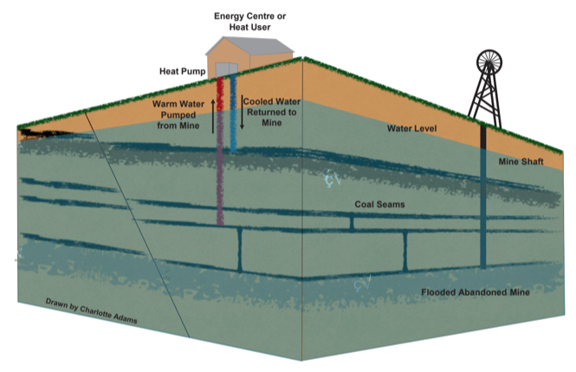

*Schematic Diagram of a mine water heat pump system (Drawn by Charlotte Adams)*

## Mine types

### Pillar and stall

This method was used in the early stage of mining and therefore characterize the oldest and shallower mine workings. It consists in working a grid, extracting about 25% of the seam (Harrison and Scott, 1987), where regularly spaced rectangular pillars of about 6 x 15 m (pillars are about 6-9 m in size and room about 9-30 m) are left to support the mine roof and areas are mined in between.

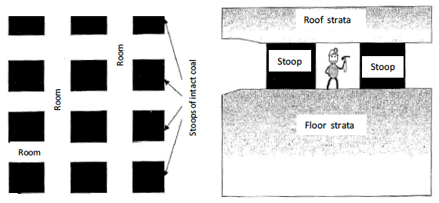

*Layout of stoop and room mine workings. Plan view on left and profile view on right. (Younger and Adams, 1999).*

### Longwall mining

Longwall mining is a method developed since 1795 and mostly used from 1950 (Atkinson, 1966). Many areas initially mined by the room-and-pillar method were latterly reworked using the longwall extraction method. This method involves driving tunnels to the farthest extent of the mine and remove coal laterally from the working face of the seam. Collieries areas were divided into sections of about 10-20 acres around which thick stone walls were built and pillars progressively removed, leading to an extraction rate of up to 80%. The coal panel between the roadways is typically 100 to 250 m wide (Younger et al., 2002), with coal face area and tailgate/headgate entries being about 4.5m and 90 m wide, respectively (Esterhuizen and Karacan, XXX). This method allowed the overburden roof above mined seams to collapse behind the advancing longwall face, forming an accumulation of block of rocks containing high void ratios called ‘goaf’. After its formation, the goaf is progressively compacted by the weight of the overburden subsiding rocks, resulting in a reduction in the void ratio over time.

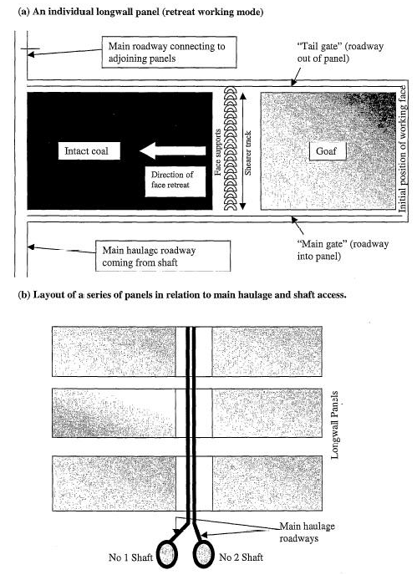

*Layout of typical longwall mine workings (Younger and Adams, 1999).*

## Estimation of void volume in mines

Several methods have been deployed to derive an estimate of the void volume in mines. The first one consists in calculating the product of the mined area and the extraction thickness of the considered seam, and adjust it for the amount of roof subsidence and for the angle of the working. Using this approach, Jossop (1999) estimated the amount of remaining void in the order of 25%, while Malolepszy (2015) suggested that 5-40% of the initial volume of the mined space remains open, depending on natural and technological conditions. The amount of remnant void space indeed highly depends on the method of deep mining employed.

In room and pillar mining method, pillars and open spaces are generally left in place, and only small and local convergence of the roof/floor is expected. Few debris resulting from roof falls are found on the floor and are assumed to be compensated by the creation of voids in the roof. Thus, it is assumed that 50% of void mines remains open and filled with water if no collapse occurs (Younger et al., 2002).

In longwall mining, the formation of goaf together with the convergence of the workings roof/floor generally tend to fill the mined area, reducing the initial void volume in the workings. Gillespie (2013) suggested that about 20% of the mine voids remain after subsidence above longwall panels. Whiteworth (2002) instead considered the existence of areas of total and partial extraction in the working. He suggested, by multiplying the workings area by the extraction thickness and considering the roadway size, that residual void volume in longwall mining area represent 10% of the extracted height in areas of total extraction. A fracture zone can moreover develop as a result of the subsidence mechanism that stresses the strata overlying the mined seam, enhancing the permeability of this rock mass. While intergranular flow would be dominant in the goaf, fracture flow is expected to be dominant in the fractured zone above it. Using typical longwall panel widths of 100-250 m, Younger and Adams (1999) estimated that the height of the fractured zone above the mined seam due to subsidence is in the range of 40 to 100 m. Nevertheless, the mined horizon is assumed to remain the most permeable zone, with a goaf porosity of about 30% (Younger and Adams, 1999).

Esterhuizen and Karacan (XXX) used a 3D geomechanical model to calculate the vertical and horizontal permeability variations in the goaf after its compaction by the overburden, and then evaluate their impact on flow and heat transfers. A reservoir model of a typical longwall panel in the Pittsburgh Coalbed (Eastern US), 1650 x 2300 ft in size, was then created based on the typical dimensions for a longwall panel (i.e. width of 1250 ft, caved thickness of 35 ft and width of the working face between the unmined coalbed and the gob of 15 ft.), including surrounding entries. The tailgate and headgate consisted of three entries each, spaced 100 ft apart. Non-uniform grids and local grid refinement were used to create twelve 1-6 ft thick layers representing rock layers above the mined seam and the details of the mining environment. This model considered three sections:

* The undisturbed rock unit, characterized by the pre-mining properties of unmined coal bed and overlying rocks
* The gob, for which porosity and permeability variations were imported from the previous compaction model
* The entries and longwall face in mining layer, characterized by high permeability (10-7 m2 or 108 mD), low resistance and high porosity (i.e. fracture porosity of 99%). Null properties were assigned to the matrix.

Another method to estimate the remaining void volume is to use coal production, the mean density of excavated rock and a factor of 25% accounting for subsidence and backfilling. Andrés et al. (2017) estimated the total void volume in the Asturias mine (NW Spain) based on the amount of infiltrated water (i.e. estimated from effective rainfall) that filled the reservoir during the groundwater rebound. This was then used to calibrate the residual void left after coal extraction, taking into account the tonnage extracted at each level, the method of operation, and the presence of shaft/galleries, resulting in an average porosity of the mined area of 20%.

## Mine structure

The permeability change induced in longwall mining has been defined by Adhikary and Guo (2015), by dividing the mine into four main deformation zones of different thickness:

* A caving zone, characterized by broken blocks of rock detached from the roof, representing 5 times the extraction thickness (in accordance with Mucho et al., 2000 and Esterhuizen and Karacan, XXX). Based on calculations of vertical and horizontal permeability distribution in a typical longwall panel during goaf formation and subsequent compaction, Esterhuizen and Karacan (XXX) moreover identified a highly permeable ‘fully caved’ zone extending about 1.5 times the mining height, rapidly decreasing in the partially caved zone.
* A fractured zone, characterized by bending of the rocks, fracturing, joint opening and bed separation, representing about 15 to 40 times the extraction height.
* A constrained zone of variable thickness, without signiﬁcant fracturing or alteration to the original geo-mechanical properties
* A surface zone less than 20 m thick, with tensile fracturing

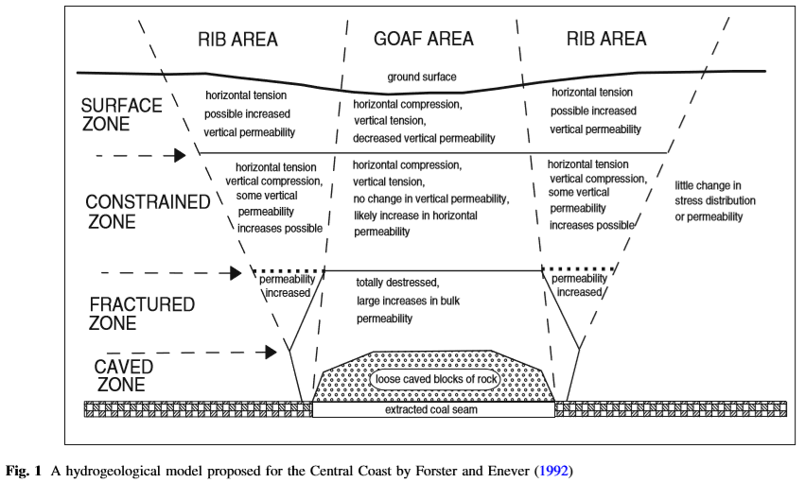

|  |  |  |  |
| --- | --- | --- | --- |
| Zone | Adhikary and Guo (2015) | AECOM, 2013 | BOOT, 2002 |
| Surface | Surface | Surface | Shallow subsurface:  Open fracturing |
| Near-surface | ~20 m | W/9 |
| Constrained | Variable | W/9 | Deformation zone:  Little fracturing + subsidence |
| Fractured | 15-40X | W/3 | Vertical fractures + horizontal bed plane separation = 30-40 X |
| Caved | 5X | Collapsed materials =  2 – 8 X |
| Fully caved | 1.5X |
| Seam | Variable | Width W |  |

From this conceptual model, Whitworth (2002) classified water inflows in mines into three categories:

* Shaft waters, which represent the major interconnection between a mine and a major aquifer (i.e. pumped to surface from shallow aquifers)
* Coal measures inflow, which includes small inflow (< 330 m3/day) from minor aquifers and large inflow from major sandstone aquifers situated above or below the workings, and flow from faults. Inflow rate from Coal Measures starts declining once the water recovery reaches the level of inflow.
* Shallow working waters, which include shaft, Coal Measures aquifer and surface waters. This water type inflow tends to affect the water level in old shallow workings in the later stages of recovery but can also gravitate to deeper workings via mine connections. There, seasonal fluctuations are linked to variations in rainfall.

# Modeling

## Introduction

Difficulties in predicting groundwater flow in coal measures mainly result from the complex geometry of interconnected voids inherited from a long mining history, not always well documented. The record of mine abandonment only started with the 1870 - Mines Inspection and Regulation Act (NRA, 1994), while the acquisition of accurate mine plans only became mandatory in 1872. Even though, data often showed only the extent of the workings and not the depth or any geological information. The acquisition of reliable data and maps only started with the nationalization of the coal industry in 1947, hence most of shallow early workings are unknown and unmapped (Henton, 1974; Richardson, 1983). Moreover, areas of extensive collapse are generally not known (Harrison and Scott, 1987).

Abandoned coal mine reservoirs can be divided in two main domains:

* The mine voids (i.e. tunnels that can be assimilated to heat exchanger of simple geometry from which the sustainable geothermal resources can be estimated by semi-empirical method or numerical model)
* The mined areas or goaf (i.e. area of complex geometry composed of fractures and secondary porosity, closely related to the mining method and the roof conditions).

Two different approaches can be considered to solve for heat transfers and fluid flow equations in mine systems, through analytical models (Pruess and Bovardsson, 1983) or numerical models (Loredo et al., 2016). Analytical models solve for the exact mathematical solutions of flow and heat transport by considering homogenous systems, and therefore require geometrical simplifications. They can be used at an early stage of a feasibility study to get a first insight into heat transfers and the sustainability of heat abstraction from geothermal systems (Banks, 2009; Loredo et al., 2017). On the contrary, numerical models allow creating more realistic representations of mining scenarios (i.e. complex geometries, heterogeneous systems…). However, they generally require more data and greater computational time and capabilities, which make them more complex to use relative to analytical models.

## Analytical solutions

See appendices.

## Numerical solutions

Numerical solutions, consisting of the Finite Difference Method (FDM), the Finite Element Method (FEM) and the Finite Volume Method (FVM), consist in solving the heat and mass flow equations through approximations. The FDM first discretizes space and time in rectangular grid, that does not represent accurately irregular boundaries and complex geometries. The FEM solutions divides the spatial domain into a mesh of elements that allows representing more complex geological boundaries. Finally, the FVM uses volume integral formulation to discretize the equations (interesting for turbulent and source term dominated flows). This approach, where the conservation laws are well respected, is mainly recommended to solve for pumping shaft analyses or in case a piping-type scheme is to be evaluated (Loredo et al., 2016).

No standard modeling approach has emerged yet when it comes to modeling fluid and heat flow in mines (Renz et al., 2009). In mine reservoir modeling, the main difficulty arises from the necessity to solve simultaneously for heat transfer, solution transport and mass flow within open pipes (i.e. galleries, roads, shafts), porous matrix and fractures (Ferket et al., 2011; Renz et al., 2009). Modeling strategies developed to predict temperature evolution in a mine system include:

* The assimilation of the mine as a porous medium with different hydraulic conductivities in which the Darcy flow for both host rocks and workings (Malolespsy, 2003)
* Hybride finite element mixing cell approach (Brouyère et al., 2008)
* 3D Navier strokes calculations (Woldersdorfer, 2008), used to model both laminar flow within 3D porous media and turbulent 1D pipe flow in mining voids (Raymond and Therrien, 2008).

While the approach from Raymond and Therrien (2008) might be the most accurate, predicting the absolute thermal capacity of a mine cannot be accurately performed using those approaches. The lack of knowledges of the lateral and vertical interconnectivity of the different parts of the mines and volumetric capacities represents significant limitations to the setup of a reliable numerical model. This adds to uncertainties in the assumed parameters and boundary conditions (i.e. lack of pre-mining thermal and hydraulic properties, cyclic changes of precipitation/evaporation…). Performing numerical calculations considering a whole complex mine system with detailed geometry would moreover require extreme computing capabilities and amount of time. Moreover, numerical instability may arise from the simultaneous solution of pipe-flow together with matrix flow, where strong contrasts between the highly conductive mine workings and less conductive host rock exist (Renz et al., 2009).

Despite calibrated models based on a porous laminar approach may be sufficient, more accurate results would be obtained by applying numerical approaches for free water flow in the mine workings, considering turbulent regime. To overcome this issue, Ferket et al. (2011) used coupled analytical models of heat transfer in mine void and discrete ‘pipe network’ hydraulic models based on the semi-empirical approach from Rodriguez et al. (2009) to determine the heat capacity of the Asturias mine in Spain. This model is able to simulate both heat transfers between water and pipe walls and advective flow within a system of complex geometry, using a hybrid node-loop approach based on the EPANET code (Rossman, 2000).Previous studies have shown the importance of the relative contribution of advective/conductive heat transfers, the impact of induced flow circuits, the time required to recover thermal equilibrium between the rock and the water after production. Results from different studies are described below.

## Previous studies

### Heat transfer in mine tunnels, Ghoreishi Madeish et al. (2012)

Ghoreishi Madeish et al. (2012) used a Finite Volume Modelling approach to evaluate the sustainable heat extraction from abandoned mine tunnel and address the issues of thermal breakthrough (Loredo et al., 2017). A tunnel of simple geometry (characterized by its length and cross section) embodies the bulk geometry of the model. In the numerical model, they assume that the water infiltration through the rock mass into the tunnel negligible compared to flow within mine gallery and that the natural convection inside the rock mass negligible in comparison to the forced convective flow inside the tunnel. As no regional hydrological gradient is assumed after the mine is fully flooded, the water movement inside the rock mass is considered non-significant (only the gradient induced by production is considered). Therefore, the only component of the flow field is the velocity of water inside and along the tunnel. Two heat transfer mechanisms are considered: forced convection inside the tunnel and conduction in the rock mass. There, the thermal properties of water are used to solve the equation of unsteady convective heat transfer in the tunnel (with w the longitudinal component of water velocity) and the thermal properties of the rock mass are used to solved for equations of unsteady heat conduction in the ground (w=0). The value of thermal conductivity is calculated at each point following the “harmonic mean method” (Patankar) so that the heat flux exchanged between the water and the ground regions is balanced. As initial condition, the rock mass and the underground water are set at an equilibrium temperature Tg. Isothermal condition is assumed for all boundaries except for r = 0 axis (adiabatic BC) and an injection temperature Tin is set at the tunnel inlet. As the temperature of water/rock mass around the tunnel inlet is lower than at the outlet, a longitudinal temperature gradient is formed, creating a conductive heat flux along the z-axis in the rock mass in addition to radial heat flux across the rock zone. During the simulation, aiming at predicting the resource reaction to different heat extraction scenarios, seasonal heat load variations are modeled by adjusting pumping flow rate through the mine tunnel.

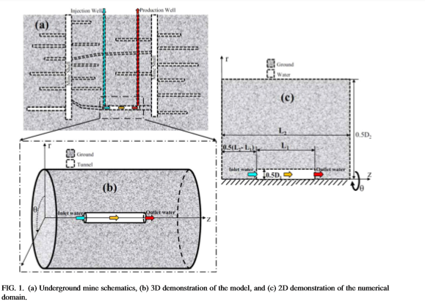

According to Ghoreishi Madeish et al. (2012), the most important parameters in modeling heat flow in mine tunnels are the thermal conductivity of the mine rocks (determine the sustainable rate of heat extraction from mines), and to a lower extent the permeability and specific heat capacity of the mine rocks. In the “mine tunnel” approach, the dimensions of the tunnel (length and cross section) impact the total recoverable heat from the mine, while the temperature of extraction depends on the rate of heat extraction from the resource. Ghoreishi Madeish et al. (2012) showed using a simple mine tunnel geometry (numerical modeling approach) that an area of up to 40 m around the tunnel is affected by heat extraction during the life time of the project. Results also show that seasonal heat extraction and seasonal use of cold/warm water from the mine allow heat recovery and is likely to better sustain the heat resource production in long term, increasing the system lifetime (Ghoreshi et al, 2012; Hall et al., 2011; Hamm and Bazargan Sabet, 2010). This procedure aloows taking advantage of the storage capacity of the underground (Ruhaak and Renz, 2010).

### Heat transfers in longwall panel (Goreishi Madiseh and Abbasy, 2015)

In 2015, Goreishi Madiseh and Abbasy performed numerical and experimental study of geothermal heat extraction from backfilled mine stopes, to assess the performance of a stope-coupled geothermal heat exchanger system, and analyze the effects of hydraulic conductivity, thermal conductivity, heat extraction rate and of the arrangement of heat exchanger tubes, considering both heat conduction and natural convection. Results showed that backfilled stopes have great potential for sustainable geothermal heat production, with the main heat transfer mechanism being conduction. However, the sustainable rate of heat extraction, which corresponds to the maximum rate at which the wanted COP can be maintained, needs to be determined accurately as it represents the main factor for the economic feasibility of a geothermal system.

### Dual-porosity medium (Guo at al., 2018)

Guo et al. (2018) also performed an evaluation of the potential and the sustainability of geothermal resources in abandoned coal mines using a numerical approach (MINC method of TOUGH2). In this model, the mine thermal reservoir (mined area) is considered as a dual-porosity medium, modelled as a typical working face formed of a caved zone and a fractured zone (the continuous zone situated on top of those and affected by elastic deformation is assumed to be an aquifuge not connected to the goaf). The caved zone, which contains the goaf material, is assumed to be isotropic while the overlying fracture zone, composed of regular vertical fractures, is anisotropic. For both zones, two types of porosity are taken into account: the primary porosity (small fractures and pores in the rock matrix), measured by experiments, and the secondary porosity (fractures induced by mining). The volume and spatial distribution of secondary fractures is calculated based on the volume of mined-out area, for different types of roof rock. The bulking factors, which represents the change in rock volume due to broken solid rock, were calculated for both the caved and fractured zones based on the height of each zone (estimated from the roof rock strength properties and the thickness of the mined seam) and on mining parameters (i.e. volume of mining coal and subsidence of the fractured zone). The exponential decrease in the bulking factor in the fractured zone with height (due to change in fracture permeability) was taken into account for the estimation of the average total bulking factor, used to calculate the total secondary porosity produced by mining. In the model, the main reservoir (caved and fracture zones) is surrounded by large a large continuous media aiming to minimize the influence of boundary conditions. Temperature equilibrium is assumed between the fluid and the rock mass as initial condition. During the simulation, injection and extraction of water is performed at both ends of the working face, and flow and heat transfer in the fractures of the mined-out area are calculated to analyze the effects of injected temperature, flow rate and lifetime on the thermal storage capacity and sustainability of the mine heat reservoir.

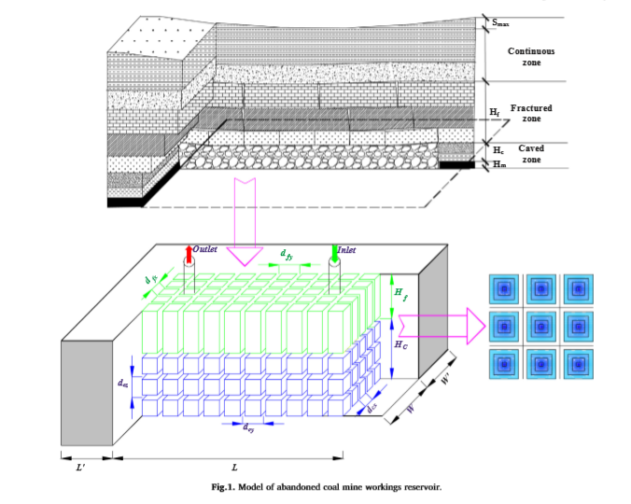

Guo et al. (2018) showed that the geothermal potential of flooded mine depends more on the height of the fracture zone than on the fracture permeability and that an increasing roof strength tends to increase the sustainability of heat production. Strong roof rock strength tends to produce wider/more sparse fracture distributions, influencing the temperature distribution and increasing the heat production. While the permeability of the roof is beneficial to heat transfer (production temperature increases with roof permeability), the fracture permeability of the fractured zone (volume/aperture) tends to decrease the production temperature. In addition, the heat extraction rate is closely related to the injection temperature and lifetime of the production. The rate of temperature drop is quicker for high flow rate and lower injection temperature, but tends to decrease with time.

### Combined 3D porous medium and 1D pipe flow (Raymond and Therrien, 2008)

Raymond and Therrien (2008) estimated the energy attainable from mine water and the geothermal potential of the ﬂooded Gaspe Mines in Quebec (Canada). Groundwater flow in the mine was simulated using the 3D finite element simulator HydroGeoSphere (Therrien et al., 2004), able to solve simultaneously for 1D pipe flow and 3D porous media flow. The 3D domain was indeed here divided in two distinct media. First, the underground roads and shafts were represented as network of 1D line elements along which pipe flow was computed. The nodal flow term for these elements was either transferred to the flow equations associated to the 3D porous medium using a fluid transfer term (Adams and Younger, 2001) or directly added to the nodal flow terms of the 3D elements of the porous medium (Boyaud and Therrien, 2004). Second, the workings were represented as a 3D sub-domain of high hydraulic conductivity relative to host rock, and geometrically constrained by maps of excavated zones and their relative elevations. Due to the lake of detailed records of the current workings state (i.e. collapse, filled workings…), hHomogeneous and isotropic values for the hydraulic conductivity, porosity and speciﬁc storage coefﬁcient were used for each sub-domain.

A 3D mesh composed of 123,000 nodes was generated by stacking 40 layers of 2D triangular elements along the vertical axis. The bottom boundary was set deep enough to minimize its influence on groundwater flow and to be considered as impermeable. Topographic highs were set as recharge areas (Dirichlet boundary conditions, constant hydraulic head), while nodes at the surface in streams/valleys were assigned a constant head equal to the surface elevation. A positive water flux representing recharge due to precipitation was assigned to the surface nodes. No flow boundaries were set on the lateral extremities of the model.

The model was first calibrated from alternated/repeated transient pumping test and steady-state groundwater ﬂow simulations. The hydraulic properties for the host rock and underground workings (hydraulic conductivities and speciﬁc storage coefﬁcients) were adjusted so that simulated drawdown reproduces the hydraulic response of the Gaspe Mines to the pumping test, considering a constant pumping rate and no infiltration at the surface. The first-type boundary conditions at topographic highs (inﬁltration ﬂux) were adjusted so that modelled drawdown match measured water table elevation before the pumping test (natural steady-state flow conditions). Calibration resulted in values for the hydraulic head before pumping and infiltration flux. Multiple simulations at various pumping rates were then used to determine area affected by pumping well (transient ﬂow conditions with no infiltration flux specified at the surface). This affected area resulting from the model drawdown predictions was multiplied by the heat ﬂux to estimate the energy rate that can be captured by the pumping well ${ E}_{c}$, which was compared to extractable energy rate $E_{hp}$. An energy balance calculation was used to estimate the geothermal potential / resource Et (J) of the mine. This approach assumes that the drawdown caused by pumping approaches steady state after a heating season and that the heat recharge to pumped water is due to the geothermal heat flux (i.e. captured energy rate), advection from inflowing groundwater, and conduction when the system starts cooling. If conduction and advection are neglected and considering that energy extraction occur only half time of the year relative to a constant heat flux, then the sustainable energy production rate corresponds to the pumping rate at which the captured energy rate $E_{c}$ is half the rate of energy extraction from water by heat pumps $E_{hp}$:

$$E_{hp}=2 ×E_{c}$$

With Ec (W) the captured energy rate, Ehp (W) the extractable energy rate from water using heat pump.

### Combined 3D/2D/1D model of porous medium and pipe flow (Renze et al., 2009)

In their study, Renze et al. (2009) used different flow equations, including the Darcy (laminar flow, e.g. Diersch, 2005), Hagen–Poiseuille (slow-moving laminar pipe flow), and Manning–Strickler (Manning’s equation for 1D pipe/channel turbulent flow, e.g. Diersch, 2005) equations to simulate fluid flow within 2D triangular finite element mesh using the FEFLOW code. A resolution of 3 to 14 m was used to simulate Darcy flow within the rock mass, and laminar and turbulent flow in the mining structures were calculated by adding 1D elements. Renz et al. (2009) indeed suggested that shafts or tunnels may be considered as 1D and coal seams as 2D, simplifying the applications of empirical flow equations for turbulent fluid flow. This simplification might however not be suitable in cases where high Rayleigh numbers allow heat transport in the system though convection, only feasible in 3D. The 2D model was based on a geological cross-section with specific rock properties. Elements representing the mining voids were divided into four types: shafts (open and with a cross sectional area of 20m²), roadways (considered as tunnels with a cross sectional area of 25 m², connecting different parts of the mine in the horizontal direction), driving and caverns, considered as a porous medium of very high hydraulic conductivity. While turbulent flow is expected in large mine voids (roadways and shafts) with high velocities and high pressure losses, laminar flow is expected in backfilled part of goaf materials, drivings and caverns, that represent the largest voids in the mines (roof elevations of 5 and 10 m, respectively) and thus contain the major portion of the mine water. As the extent of those are mainly horizontal (i.e. orthogonal to the plan of the 2D model), the real behavior of heat and mass flow in these voids cannot be reliably simulated. Their ability to store large amount of water (i.e. thermal energy) was therefore represented by a heat capacity equivalent to the complete depth, applied to the 1D elements. Initial conditions were calculated from the boundary conditions in a steady-state simulation without injection and extraction of mine water.

In the density-dependent simulation, results showed that movement due to free convection were negligible, showing insignificant density effects. In the heat extraction/injection simulation, cold water was injected at the bottom of the shaft at a constant temperature of 3°C and a flow rate of 120 m3/day. Results show that the Strickler coefficients (roughness coefficient that determine the pressure loss due to friction between the fluid and channel walls in the Manning-Strickler equation) have little influence on the modelled temperature evolution. A 3D model was then set up using a 3D porous media approach to get volumetric information on the heat transfer resulting from geothermal operation. The mesh was composed of 600000 nodes of prismatic elements.

The table below summarized the BC used for the 2D and 3D models.

|  |  |  |
| --- | --- | --- |
|  | 2D | 3D |
| TOP BC | Impermeable boundaries  fixed T°= 10°C | Head = river level  Recharge = 90 mm/s  fixed T°= 10°C |
| BOTTOM BC | Impermeable boundaries  constant geothermal flux | Impermeable boundaries  constant geothermal flux |
| LATERAL BC | Impermeable boundaries | Impermeable boundaries |
| EXTRACTION /  INJECTION POINTS | hydraulic head h = 0 m | -extraction at the bottom of the deepest shaft  -injection: constant T°=3°C at the bottom of the model |
| HYDRAULIC CONDUCTIVITY   * Shafts / caverns * Drivings/ roadways |  | n = 1  K = 5 m/s $ρ$ c = 4.2 x 106 J/m3.K  k = 0.65 W/m.K |

Renz et al. (2019) compared the classic Darcy flow modelling approach to the 1D/2D model. They showed that for conductivity contrast between the mine void and the rock <10 5 m/s, the higher the mine void conductivity, the smaller the decrease in extraction temperature. Above contrasts of 10 5 m/s, the greater the mine voids hydraulic conductivity and the greater/quicker is the decrease in extraction temperature. For low K, the cold water mainly flows within the lowermost galleries and is separated from the warm water above due to density effects. From K=104 m/s, mixing of warm and cold water occur as a result of the establishment of free convection within the mine voids, leading to faster transport of cold water toward the extraction well **(layering of cold/warm water is therefore only possible for a certain range of hydraulic conductivity values)**. The major benefit of the porous medium approach is therefore that it takes into account the effects of free convection. However, the overall heat storage from large mining voids are not properly accounted for as in the 1D/2D model.

### Hamm and Bazargan Sabet (2010)

Hamm and Bazargan Sabet (2010) used a numerical modeling of fluid flow and heat transfer to assess the geothermal potential of a flooded coal mine in Lorraine (France). The models take into account the geometry of the mine working networks to determine precisely the thermal breakthrough, and validated by fitting in-situ flooding tests. In an initial model composed of ~1M tetrahedral elements was run to simulate free convection within the shaft induced by water density differences, to determine the resulting steady-state mixing temperature together with an estimate of a critical value of the fluid thermal Rayleigh number. As for the previous analysis, the water in the reservoir and the surrounding rocks are assumed to be initially in thermal equilibrium. A constant geothermal gradient and a fixed temperature boundary between the shaft wall and the surrounding rocks are defined. Using MARTHE software, the temperature evolution of the production zone over time was then calculated for different production/injection rates. A model of more than 1M hexahedral elements was used, representing a sub-set of three levels of galleries among 18 levels modelled from 193m to 1250m depth. Two regimes were considered in the mine voids: high-velocity in the network of highly conductive shafts/galleries (special porous media where porosity is such that the section open to flow is equal to the gallery/shaft cross-section) and low-velocity in the less permeable porous rock mass (considering a **ratio between the gallery/shaft and rock permeabilities of 105**). In this approach, it is assumed no direct hydraulic and thermal connection between the production zone and the upper galleries through the production shaft.

Hamm and Bazargan Sabet (2010) suggest that the assumption of equivalent porous media for mine workings is adequate when considering large-scale modelling. However, this approach can be be improved by using a multi-layer model taking into account detailed digital maps of the mine’s galleries/shafts, better describing the 3D geometrical and hydraulic connections in the mines.

### Malolepszy (2015)

Malolepszy (2015) used two 2D TOUGH2 numerical models to simulate heat exchanges and temperature recovery of abandoned coal mine workings in the Nowa Ruda coal mine in Poland. With an average geothermal gradient of 32°C/km in Polish coal fields, temperatures of 30-50°C are expected at the deepest levels of the mines. Low-conductivity horizontal rock layers constitute cap rocks for the inflow of geothermal heat, potentially leading to thermal anomalies beneath thick layers of coal-bearing formations. In flooded mines, other local thermal anomalies might be due to mineral oxidation processes that tend to disturb the natural thermal regime of the mine (Jessop 1995). The first 2D model was built based on a vertical geological cross-section that preserved natural dips and thickness of the rock beds. This model was used to calculate natural-state conditions, simulate the conditions under mining activity (assuming a cooling of 8C) and the temperature recovery in the working after the stop of the mining activities. Results showed that the time required for temperature to return to natural thermal conditions in a rock massif where cooling has occurred is about 10 years. A second planar model, representing a 50m thick layer of rocks in the deeper part of the abandoned workings of the Piast mining field, was then used to simulate natural conditions, assuming terrestrial heat flow from the lowest part of the model. Scenarios of production /injection of mine water were then simulated with flow rates of 10 and 20 l/s. The model used a well doublet with a separation distance of 1.5 km, consisting of a producer well extracting 23C water at 660m depth and an injection well drilled down to 350 m and injecting water at 2-4°C. Results indicated a cooling by 4°C for 10 l/s and 10°C for 20 l/s.

### Andrés et al. (2017)

Andrés et al. (2017) performed a 2D model of the area between the Barredo and Figaredo shafts (NW Spain) to calibrate the hydrogeological and thermal properties of the mine reservoir, considering the workings and interconnections between them. Three classes of materials where used: the unaltered rock, the mined volume and open voids. In this model, the size of the elements varied from 2.5 around the galleries to 20 m in the unaffected and nearly impermeable rock mass (unconfined isotropic and heterogeneous porous medium). Galleries were assumed to have a rectangular cross section of 8m² and a height of 2.5m, while the shafts were assumed to have a circular section of 25 m². The mined volume (altered material in the zone extending between galleries) were assigned a range of porosity between 2 and 22%, while porosities of 0.1% and 100% were assigned to the unaltered rock mass and galleries. Hydraulic conductivities of 10-7 and 1 m/s were assumed for the unaffected rock mass (Fandos et al., 2004) and the shaft/galleries, respectively. A porosity and hydraulic conductivity of 1% and 10-3 m/s were assigned to the Barredo fault. Ordonez et al. (2012) moreover estimated that the recharge of the Barredo-Figaredo reservoir consisted of a total infiltration representing 23% of the effective rainfall together with a constant water loss from rivers of 5300 m3/day, with the total recharge being equivalent to the average pumping rate. Thermal simulation started after the flooding simulation period, for a constant water level. Variable temperatures representing daily air temperature were set as top boundary condition. A constant flow of 65 mW/m² was set as bottom boundary condition. The temperature of the rock mass at the surface was set to 13°C as an initial condition, while temperature at depth was calculated based on the geothermal gradient, reaching up to 33 °C. 3D models was then developed, requiring simplifications to account for the complexity of the mine galleries. There, galleries at each level were represented by slices of 2.5m height. For each slice, an average porosity of 10% and hydraulic conductivity of 0.5 m/s were assigned to the mined areas where galleries extend, while the mined volume around these zones of galleries and shafts were assigned a porosity of 1% and 100%, respectively. A porosity of 0.1 % was kept for the unaffected rock mass and hyraulic conductivities of 10-7, 2 x 10-4, and 1 m/s were considered for the unaltered rock mass, the mined volume (zone affected by coal extraction), and the shafts, respectively. In this model, an increased number of nodes were necessary to represent the galleries to avoid convergence errors. Conclusions showed that the temperature of the reinjected water after used in a heating cycle is higher than the average natural recharge water. However, long-term simulations showed that a new equilibrium is set between the cold reinjected water pumped again at 100-200m depth and the surrounding rock below the pump, subsequently leading to a maintain of the abstracted water temperature (Andrés et al., 2017).

## Boundary conditions

Numerical approaches require the definition of boundary conditions (BC). Physical hydrological features are generally selected to bound the studies domain (Wels, 2015). In mine systems, hydraulic BC are generally defined as (Loredo et al., 2016):

* Fixed hydraulic head (Dirichlet BC) at water bodies
* No-flow BC (Neumann) at the lateral boundaries when model delimited by river
* Cauchy BC, to simulate surface stream drainage (i.e. Baier et al., 2011)
* Pumping rate and rainfall recharge

Similarly, thermal BC are described as:

* Constant temperature in upper boundary (i.e. annual average soil or air temperature over a long-term) (Banks, 2012)
* Heat Flux (Neumann) used at the basal boundary

## Initial conditions

Modelling of monitored water recovery in mines using inflow data or pumping rate has been used to calculate inflow rate and predict the timing, site and flow rate of potential water discharged from mines (Whitworth, 2002). Steady state models can be used as input to set the initial conditions of predictive models of temperature change under production (i.e. initial head and temperature).

## Data requirements

The hydrological components of flooded mine workings system and their interactions in response to production need to be understood to determine the long-term sustainability of a mine working as thermal resource (Burnside et al., 2016). Both regional groundwater conditions and the speciﬁcity of mine dewatering operations are required to build groundwater ﬂow models (Szczepinski, 2019).

The table below summarizes the hydro-chemical-geological data (i.e. material properties, thermal and hydraulic parameters), geometrical data (i.e. mine structure) and production data (i.e. flow rate, temperature) required to build a mine reservoir model, together where the sources of data.

|  |  |
| --- | --- |
| Data requirement | Source |
| Groundwater level (hydraulic head) | Environment Agency (EA) boreholes, British Coal / Mining Company records |
| Pumping rates and dewatering history + mine water inflows during operation | British Coal / Mining Company records |
| Regional hydrology (i.e. average rainfall, river infiltration, surface runoff, evapotranspiration) | EA rainfall data, EA runoff data, MORECS evaporation / soil moisture deficit data |
| Surface Discharge rates | Coal Authority |
| Reservoir temperature |  |
| Surface topology | Ordonnance Survey mappings |
| Geological disturbances (i.e. faults) | BGS mapping, Coal Authority |
| Strata type and thickness (deposits and mined layers, chemistry, intrusions…) | BGS mapping, mine plans, shaft drilling records, coal Authority |
| Seam elevation and location of outcrops | BGS mapping, mine plans, shaft drilling records, Coal Authority |
| Coal Seam outcrops | Coal Authority |
| Mine geometry and hydraulic connections between mine workings (Farr et al., 2016) | Mine plans, Coal Authority, BGS mapping |
| Location/type and interconnections of workings | Mine plans, Coal Authority |
| Location roadways, shafts, galleries | Mine plans, Coal Authority |
| Abandonment state (backfill, cement, collapse) |  |
| Location of monitoring points (i.e. outflow, temperatures) | Coal Authority |
| Boundary conditions (i.e. hydraulic barriers) | BGS regional hydrogeological mapping, EA measured levels |
| Porosity (+ tortuosity) | EA pumping tests, literature |
| Specific Yields / storage | EA pumping tests, literature |
| Hydraulics conductivity | EA pumping tests, literature |
| Pipe length / diameter / roughness | Mine plans, literature |
| Node elevation | Mine plans |
| Location and elevation of fixed head (i.e. adits, shafts) | Mine plans, BGS mapping |
| Monitoring data (EC, temperature profiles, temperature evolution, water levels, pumping tests, geochemical analysis) | Coal Authority: <http://mapapps2.bgs.ac.uk/coalauthority/home.html> |
| Rock thermal conductivity, density, thermal capacity, thermal diffusivity, mass dispersivity | Literature |
| Water density, viscosity, heat capacity, thermal conductivity | Literature |
| Solar flux | Literature, remote sensing data analysis |

Farr et al. (2016) also underlined the value of monitoring mine water chemical composition (i.e. pH, electrical conductivity oxidation reduction potential, dissolved oxygen and alkalinity) and the necessity to study of mineral stability in mine reservoir modeling. Such analysis can support 1) the characterization of the annual temperature variations of mine water discharges, 2) the estimation of possible contribution of exothermic reactions to mine water temperature, 3) the description of the geothermal gradient and 4) the estimation of the heat potential from mine water discharges. Technical parameters such as the length of the well screen Ls (m) and well casing and screen radius rc and rs (Raymond and Therrien, 2008) might also be considered when estimating the extractable energy from mines.

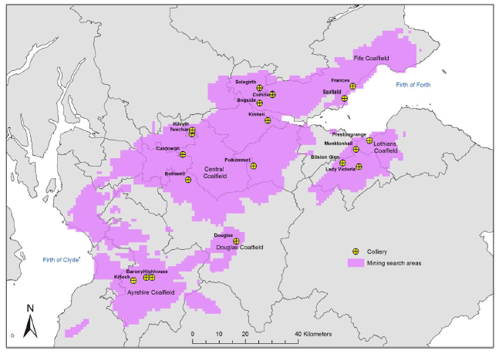

*Mineshafts in the MVS (Gillespie et al., 2013)*

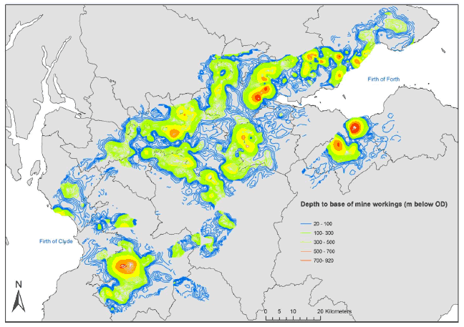

*Depth of mine workings viewed in GOCAD ® (©Paradigm) 3D modelling software, showing deepest workings in orange and red (Gillespie et al., 2013)*

# phD research project

## Research points

See phD plan

## Potential case studies

* Mine water scheme in Dawdon/Hawthorn/Seaham (pumping implemented in 2004/2008):
  + Project of implementation of a heating scheme (3 MW) for a new village (14000 houses, school…) in December 2019 (starting of heat extraction in 2020-20021?)
  + Commercial / HP retro-fit opportunities. Support of the Zero-Carbon objective. 20M£ provided by the Cabinet Office.
* Lanchester: has been using heat from a loop system of production/injection for 6 months (only 1 MW extracted over the 4 MW planned).

## Modeling approach

### Modeling tool

OpenGeoSys (OGS) is an open source scientific code for the simulation of fully coupled effects of thermo-hydro-mechanical-chemical (THMC) processes in fractured porous media (Kolditz et al., 2012), based on finite element simulator and object-oriented concepts. The complexity of such codes, which depends on the balance equations for mass, momentum and energy conservation laws, come from the different characteristic factures in terms of spatial extent, temporal scale, nonlinearities, interaction between processes. This code has been used to simulate geothermal processes in the earth’s subsurface, such has borehole heat exchanger (Boockmeyer and Bauer, 2014) or geothermal reservoir analysis (Watanabe, 2012).

Velez et al. (2018) used the OpenGeoSys (Bottcher et al., 2016) software to assess the geothermal potential of the Nevado del Ruiz volcano, based on laboratory measurement of thermal conductivity on rock samples and numerical modeling. Steady states simulations of coupled groundwater flow and heat transfer were conducted assuming two different thermal conductivity scenarios. The model consists of a numerical representation of a 2D geological cross-section, taking into account the topography and its effects on the heat flow (Westaway and Younger, 2013). The mesh, refined at the top to capture topographic variations, was created using GMSH (Geuzaine and Remacle, 2009). Hydraulic boundary conditions consist of a constant hydraulic head corresponding to the topographic elevation at the lateral extremities and impermeable no-flow boundaries at the top/bottom. Thermal boundary conditions consist of a constant temperature at the top, adiabatic conditions at the lateral extremities and a linearly variable heat flux at the bottom. Here, the authors consider the existence of an internal generation of heat by decay of radioactive elements. A set of simulations are run to optimize the domain depth, aiming to minimize the impact of vertical heat transfer on simulated surface temperature, and the mesh size. The volumetric heat resource estimation was then performed based on the temperature distribution at depth and the thermal energy content of a 1km² area. The available subsurface heat per unit width of reservoir, calculated from the temperature distribution, was used to calculated the total stored heat reserves, considering a recovery factor for fractured aquifer R= 2.4% (Calcagno et al., 2014) and an exploitation time t=30 yrs. Uncertainty analysis of the geothermal potential was finally performed using @RISK software (Ofwona, 2008) based on stochastic simulations, using 10 000 Monte Carlo iterations with varying temperature and recovery factors (Velez et al., 2018).

### Model set up

#### Parameters

In addition to the thermal and hydraulic properties of the reservoir rock and mine workings (Raymond and Therrien, 2008), modeling inputs parameters include the reservoir characteristics (Velez et al., 2018), production data and boundary conditions. The parameters to consider to model flow and heat transfers with OpenGeoSys are summarized in the table below.

|  |  |
| --- | --- |
| Material solid properties | Porosity, tortuosity, storage, hydraulic conductivity, mass dispersion |
| Material properties | Density, thermal conductivity, thermal capacity, thermal diffusivity |
| Fluid properties | Type, density, viscosity, heat capacity, thermal conductivity |
| Initial/boundary condition | Hydraulic head,  reservoir temperature, geothermal gradient, surface temperature |
| Simulation parameters | Time steps, duration |
| Source terms | Production/injection rate, injection temperature  Natural recharge/discharge (precipitation, river infiltration - i.e. Pruess and Bovardsson, 1983)  Thermal/solar flux |
| Geometrical (mesh) | Length and radius of the reinjection channel  Lateral/vertical interconnectivity of the parts of the mines (Watzlaf and Ackmann, 2006). |

*Heat flux = Geothermal gradient estimated from temperature profile x thermal conductivity*





*Data in blue are from Guo et al. (2018), data in green are from Raymond and Therrien (2008) and data in gray are porosity from the Scottish coal measures obtained from Gillespie et al. (2013).*

#### Meshing

|  |  |  |
| --- | --- | --- |
| Parameter | Value | Desciption |
| w | 1000 | width model |
| h | 700 | height model |
| d | 100 | depth first seam |
| t | 5 | seam (including fully caved zone) thickness |
| c | 10 | caved zone thickness |
| f | 85 | depth fracture zone |
| surf | 30 | depth surface zone |
| l | 100 | well searation distance |
| r | 4 | well radius |
| s | 25 | underlying seam separation distance |
| lc | 20 | large mesh |
| lf | t/2 | fine mesh |

#### Modeling scenarios

The modeling scenarios will aim to evaluate the impacts of the different source of heat in mines on the mine water temperature. A sensitivity analysis will therefore be performed based on simulating heat extraction from mine, using possible ranges of value for:

* Rock type properties (i.e. thermal and hydraulic conductivity)
* Radioactive decay (presence of a local source of energy production)
* Geochemical interactions (pyrite oxidation due to dewatering of the mine)
* Influence of faults (recharge/barrier)

In a first time, 2-D models will be used to test different geothermal set up and study the impact of parameter variations thanks to their short computation times. Those models are appropriate for preliminary studies and can be used for sensitivity analysis and to test different numerical approaches that would help calibrating future 3D models (Renz et al., 2009).

# Appendix

## Heat equations

### Available heat

The vailable subsurface heat ${ Q}_{r}$ (J/m) per unit width of reservoir, depends on $ρ$ the rock density (kg/m3), c (J/Kg.K) the rock capacity, A (m2) the area surrounding each selected point in the zone of interest, $T_{d}$ and $T_{0}$ the temperatures at depth in the zone of interest and at surface, respectively (Velez et al., 2018).

$$Q_{r}=ρcA\left(T_{d}-T_{0}\right)$$

Similarly, the rate $E_{hp}$ at which geothermal energy can be extracted using heat pumps can be estimated as (Raymond and Therrien, 2008):

$$E_{hp}=Q\left(T_{p}-T_{r}\right)ρ_{w}{Cp}_{w}$$

*with Q the average flow rate, Tp water temperature and Tr the exchanger return temperature*

Total heat stored $P_{G}$ (W) considering recovery factor for fractured aquifer R= 2.4% (Calcagno et al., 2014) and exploitation time t=30 yrs

$$P_{G}=R.\frac{Q_{r}}{t}$$

Raymond and Therrien (2008) performed an energy resource assessment, consisting in estimating the total geothermal energy content of the mine from the sum of the energy associated with each ﬂooded underground section $E_{r}$:

$$E_{r}=Vz∝ρ_{w}c_{pw}$$

*with $V$ the volume of water in a mine section, $z$ its average depth, α the measured geothermal gradient. It is assumed that the heat exchanger return temperature is equal to the ground surface temperature above the considered mine section. Moreover, the volume of void is calculated as the product of the area of excavated section by its average thickness and a correction factor of 0.25 accounting for subsidence, pillars and blackfill in the workings (Jossop et al., 1995))*

### Governing equations

Conservation of mass, energy and momentum (Loredo et al., 2016)

$$∇\overset{→}{V}=0$$

$\frac{d\overset{→}{V}}{dt}=\left(\overset{→}{V}. ∇\right)\overset{→}{V}=\frac{1}{ρ}∇p+v∇^{2}\overset{→}{V}+\overset{→}{f}$ (convective and diffusion terms)

$$ρc_{p}\left[\frac{dT}{dt}+\left(\overset{→}{V}. ∇\right)T\right]=k∇^{2}T+D$$

With $\overset{→}{V}$ the velocity field, t the time, $ρ_{w}$ water density, P the pressure, µ nthe kinematic viscosity, $\overset{→}{f}$ the body force per unit mass, $c_{p}$ specific heat at constant pressure, T the temperature, k the thermal conductivity and D the dissipation function.

### Conduction in 1D

Considering a 1-dimensional (1D) layer and assuming that the change in temperatures in each d long elements in the vertical direction are only due to conduction of heat between the elements, the amount of energy transferred $Q_{ij}^{t}$ between the elements *i* and *j* at the time step *t* is

$$Q_{ij}^{t}=kA\frac{dT}{dt}=\frac{kA}{d}\left(T_{i}^{t}-T_{j}^{t}\right)$$

The heat flow out of the element *j* becomes the heat flow in the element $i$ (G. Gunnarsson, Orkuveita Reykjavíkur, personal communication, 2017). Based on the heat diffusion equation,

$$<ρβ>V\frac{dT}{dt}=\sum{Q_{ij}^{t}}$$

where $<ρβ>$ is the volumetric heat capacity of the wet rock (J/m3°C) and *V* the volume of each element, the temperature decrease in the element $i$ at time $t+1$ is (Axelsson, 2012a):

$$T_{i}^{t+1}=T_{i}^{t}+\frac{1}{<ρβ>V}\frac{kA}{d}\left(T_{i+1}^{t}-2T_{i}^{t}+T_{i-1}^{t}\right)∆t$$

*With the $ρ=2200 kg/m^{3}$ and $β=1300 J/kgK$ the density and heat capacity of the “wet” rock respectively, the reservoir area A = 1.9 km², the thickness of each element d = 50 m, k = 2.5 W/(K.m) the conductive heat coefficient and $∆t$ the time step (assumed to be 1 year)*

The rate of temperature change of the reservoir rockdue to cold inflow is:

$$\dot{{∆T}_{r}}=\frac{m_{p}β_{p}T_{p}-m_{i}β_{i}T_{i}}{β_{r}ρ_{r}V_{r}}t$$

### Bernouilli equation for pipe flow

Gross head = entry loss + velocity head + friction head loss

$$H=\frac{0.5V^{2}}{2g}+\frac{V^{2}}{2g}+\frac{λLV^{2}}{2gD}$$

With V the velocity of flow in the pipe, H the head in the pond, g the acceleration due to gravity, D the pipe diameter, L the pipe length and $λ$ a non-dimensional coefficient which is a function of the roughness and diameter of the pipe.

## Analytical approaches

Loredo et al. (2017) compared two different commonly used analytical models of heat exchange in a mine tunnel: the Lauwerier-Pruess-Bodvarsson model (Lauwerier, 1955; Pruess and Bodvarsson, 1983) and the Rodríguez and Díaz (2009) model.

### Lauwerier-Pruess-Bodvarsson model (Lauwerier, 1955; Pruess and Bodvarsson, 1983)

In the analytical approach from Pruess and Bovardson (1983), the geometry consists of a circular mine tunnel $2r_{g}$ (Rodríguez and Díaz, 2009) with radially divergent conductive heat transfer. Simulations were performed for different abstraction/injection rates, considering a porosity of 1 for open tunnels and a porosity comprised between 0 and 1 for mined area (Bazargan et al., 2008). This model, originally developed for planar or tabular flow horizons (i.e. aquifer layers or fractures) rather than quasi-circular mine tunnels, considers dimensional parallel heat conduction away from the water-bearing horizon or fracture instead of radial divergent heat transfer, and thus appeared to yields very conservative (i.e. low) values of mine tunnel heat exchange capacity. This approach would therefore be more applicable to planar or tabular mined void geometries.

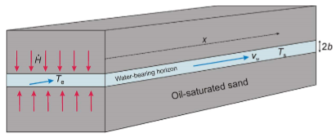

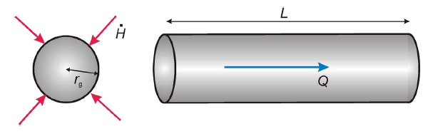

*Scheme of a mine gallery as an approximately circular tunnel with radial heat flow ( $r_{g}$ is the tunnel radius, H the heat flow to/from tunnel, Q the volumetric water flow rate and L the tunnel length).*

Formula to predict the temperature $T_{s}$ of water in a fracture of aperture 2b at time t and distance x where water injection commences at x= 0 and t =0; with $T_{e}$ the injected water temperature and $T_{r}$ the hist rock initial temperature.

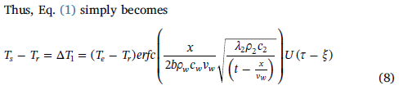

Considering, $2bv_{w}ρ_{w}=\frac{q}{w}$, with the flow velocity $v$, the aperture $2b$, the injection flow rate $q$ and the fracture unit width $w$. The fracture surface area S between the point of injection and point of observation (x) is $2wx=Px=S$, with P the effective perimeter, perpendicular to flow direction, for any generalized flow void. The linear transport time to travel a distance x:

$$\frac{x}{v}=\frac{xAρ_{w}}{q}$$

Thus, for a generalized flow channel,

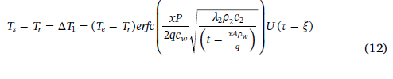

### Rodríguez and Díaz (2009) model

Rodriguez and Diaz (2009) developed an algorithm to predict the temperature of produced mine water by considering a mine as a big heat exchanger consisting of an open pipe (Ferket et al., 2011). The model assumes an approximately radial flow geometry from the outset, dividing the mine gallery, shaft or tunnel of radius $r_{g}$ into a series of sections of length $l_{i}$. The water flow at a rate Cf through the galleries with invariant characteristics except temperature. The fluid comes at a temperature of Tf and goes out through the opposite entrance. The rock mass temperature, T0 (about 25°C), is higher than Tf and thus heat transfer is simulated as pure conduction between the rock mass and the circulating mine water through an iterative process that generates the temperature output of each slice based on the result of the preceding one. The heat power gain can here be expressed as:

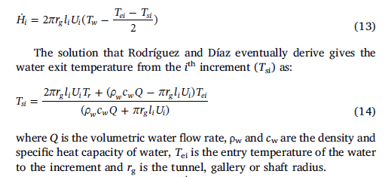

The water exit temperature from the ith increment is:

$$T_{si}=\frac{2πrl_{i}U_{i}T_{0}+\left(ρ_{fi}C_{fi}c_{efi}-πrl_{i}U_{i}\right)T_{ei}}{ρ_{fi}C_{fi}c_{efi}-πrl_{i}U_{i}}$$

With Q the volumetric water flow rate, Tei is the entry temperature of the water to the increment and $r_{g}$ in the tunnel, gallery or shaft radius. The heat transfer coefficient hi is given by combing the Nusselt (Nu), Reynolds (Re) and Prandtl (Pr) numbers of the fluid in the tunnel.

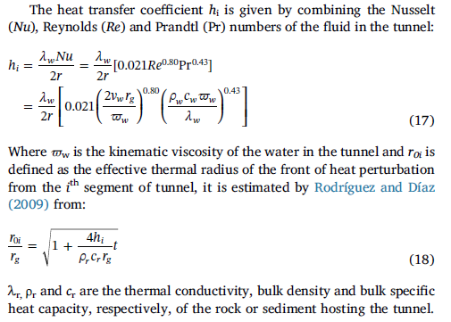

Where $w_{w}$ is the kinematic viscosity of the water in the tunnel and $r_{0i}$ is the effective thermal radius of the front of heat perturbation from the ith segment of the tunnel, estimated from (Rodriguez and Diaz, 2009):



With $λ_{r}$, $ρ_{r}$ and $c_{r}$ the thermal conductivity, bulk density and bulk specific heat capacity of the rock/sediment hosting the tunnel.

Rodriguez and Diaz (2009) simulated a geothermal energy recovery system consisting of two wells drilled from the surface to the galleries, used as heat exchanger. Cold water is injected at one well and extracted at the same rate at another well. Pressure in the galleries, which have a cross sections of 10-15 m², is at 5 MPa, and the well diameter about 220 mm. Permeability of the rock mass is set very low to avoid water losses from the tunnel. Results showed that the rock mass around the gallery is progressively cooling with time and thus, the abstracted water temperature decreases. However, this rock mass is heated again when the system is stopped and thus the recovery power increases.

According to Loredo et al. (2017) this approach for modeling heat exchange capacities for mine tunnels is more realistic as it assumes radial and divergent heat conduction from/to the tunnel. However, it presents two weak points. The first one arises from the derivation of $r_{0i}$, the effective thermal radius of the front of heat perturbation from the ith segment of the tunnel (Rodriguez and Diaz, 2009). This mode, which relies on a false concept of finite limit to temperature disturbance and inappropriate approximations of the initial tunnel wall temperature, tends to overestimates the radius of the thermal front, thus underestimating the overall heat exchange. The second one is related to the Nusselt number. The model, which here assumes turbulent flow conditions that might not be appropriate as laminar flow regime is expected in large diameter tunnels, would thus tend to overestimate the heat transfer. Appropriate Nu number is required to accurately simulate heat exchange in conduit-like mine tunnels and roadways (Loredo et al., 2017). Ferket et al. (2011) moreover suggested that while this model works well for dry mines where water is pumped for geothermal purposes, it becomes less accurate for more complex geometries and if advection from the rock mass occur.

## Temperature correction for paleoclimatic effects

Paleoclimate corrections account for the increase in temperature at the Earth’s surface that propagates slowly downward into the subsurface. It appears as a “tiny temperature deviations imposed on the geothermal gradient” (Bodri and Cermak, 2007), generally resulting in underestimation of the heat flow and thus of the potential of an underlying geothermal resource.

Evaluating precisely the terrestrial heat flux density is essential to evaluate deep geothermal potential. Marquez et al. (XXX) developed an approach to increase the accuracy of the geothermal heat flow by combining conductivity profiles estimated during thermal response tests (TRT) in ground heat exchangers (100m depth) with undisturbed temperature profile measurements in same boreholes, corrected for paleoclimate effects (Westaway and Younger, 2013). Temperature profiles were corrected by approximating the past surface temperature variations as a series of step changes of 5K before present day (Jessop, 1990), resulting in an increased temperature at depth.

A transient 1D conductive heat transfer FEM model (COMSOL Multiphysics) was developed from the inversion of thermal conductivity profiles (Raymond et al., 2016), and used to reproduce corrected temperature profile. In this model, the thermal properties of the layers were assumed uniform and constant over time, and heat due to radioactive decay is neglected. A sensitivity analysis was performed to improve the mesh resolution and the position of the bottom heat flow boundary condition so as to minimize its influence on the propagation of temperature change at the surface. A finer mesh was defined in the part affected by seasonal variations to reproduce temperature profile. The depth of the bottom boundary was increased until an insignificant relative difference between the simulated temperature at a given depth was achieved. A constant basal heat flow **q (W/m²)** imposed at the bottom boundary was optimize by running multiple simulationsonce the model proved to be independent of the mesh resolution and position of the bottom BC, with the **initial temperature distribution recalculated each time.** The upper boundary was assigned relative temperature change defined by historical surface temperature variations (i.e. air temperature converted to ground surface temperature according to Ouzzane et al. (2015). The temperature during the interglacial periods was assumed to be equal to the present day mean annual ground temperature (Allis, 1978; Jessop, 1990). Those relative temperature changes were set so the temperature at the beginning of the simulation matches the initial surface temperature inferred from the undisturbed geothermal gradient measured at the bottom of the boreholes (i.e. less influenced by surface temperature variations) extrapolated upward according to the equilibrium geothermal gradient (Raymond et al., 2016). The authors suggest that near surface heat flow estimation need to be complemented by heat flow assessment from deeper boreholes, in order to assess if effect of climate warming can be adequately considered when modeling the temperature profiles of shallow boreholes.

The corrected temperature is computed at each depth z (m) of a temperature profile and depends on the duration of the glacial periods, the temperature drop with respect to the present surface average temperature and the thermal diffusivity $∝_{s}$ (m²/s) of the rocks (Jessop, 1990), with $T_{m}$ the temperature measured at each depth (in K).

$$T_{c}=T_{m}-\sum{\left(T_{i}\right)}.\left(\operatorname{erf}\left(\frac{z}{2\sqrt{∝_{s}t_{i1}}}\right)-\operatorname{erf}\left(\frac{z}{2\sqrt{∝_{s}t_{i2}}}\right)\right)$$

The temperature distribution with depth can be calculated as (Merquez et al. (XXX)):

$$T_{i}=T_{s}+\frac{q}{λ_{s}}.z$$

With $λ_{s}$ (W/m.K) is the subsurface thermal conductivity and z (m) is the depth.

Conversion of air temperature c to ground surface temperature (Ouzzane et al., 2015):

$$T_{g}=17.898+0.951 T_{amb}$$

$$T_{g}= T_{amb}+4K$$

A methodology to apply Paleoclimatic Correction on shallow temperatures is described below (Majorowicz et al., 2012).

* Use equilibrium temperature logs (i.e. reaching a depth below the influence of the postglacial warming).
* Create models of conductivity and heat production: extrapolate up to the surface gradient and heat flow determined by linear fit of the measured curve
  + Heat flow = product of the mean gradient in the layer (i.e. 21 K/km) and thermal conductivity assumed for the corresponding layer rock (i.e. granite 2.7 W/(m K)).
  + Use proper rock conductivity values for sediments (i.e. 2.4 and 2.7 W/(m K)). Those are increased by a factor of 1.62 (frozen/melted conductivity ratio: 3.4/2.1 = 1.62) in the assumed permafrost zone close to the surface).
* Mean heat production in granite, 3-4 µW/m3 (based on Gamma spectral log (U TH K channels).
* Inversion of the measured T-z profiles in granites between 550 m – 2320 m using estimates of thermal conductivity (TC) and diffusivity of 1.44 * 10-6 m2/s, calculated according the formula:

Diffusivity (10-6 m2/s)=0.503*TC+0.0839

* Use corrected surface and deep temperatures to calculate geothermal gradient (gradT)
* Estimate thermal conductivity of rocks with depth. Lower thermal conductivities in the deep basin results generally result from the combination of 1) higher % of low conductivity rocks and 2) a decrease in thermal conductivity of rocks with increasing temperature, that generally leads to higher geothermal gradients

Heat flow at depth z is therefore: Q = Qrc+TCz x grad(Tz)

where Qrc = heat flow correction (mW/m2); grad (Tz)= uncorrected geothermal gradient effected by to the post-glacial warming at depth z.

## Mine voids definitions

The thermal capacity of a mines mainly depends on the total volume of water-filled space and on its temperature (Jessop, 1999). Void space in a mine can be divided in four types (Banks et al., 2010), described below.

### Void space in workings $V_{z}$ (Rogoż 1974; Rogoż et al. 1999)

Estimations of void space in working, mostly based on geometric and geotechnical calculations.

$$V_{z}=\frac{cA_{z}M_{z}}{cos∝}$$

With $A_{z}$ the area of the worked seam, $M_{z}$ the exploited thickness of the seam, α dip of seam and c the available porosity in mine void (i.e. water capacity coefficient in Malolespszy, 2015). This parameter mainly depends on the depth of exploitation and the type of abandonment of mine workings:

* + - c=0.485e(-0.00205H) for controlled collapse to goaf
    - c=0.275e(-0.0003675H) for hydraulic backfilling of workings with sand slurry
    - c=(P-S)/100; S=(40-19p0.2)/100 for dry backfilling of workings

With H the depth of seam below ground (m), P = porosity of backﬁll (%), p = pressure exerted by rock overburden on seam (MPa), S = pressure-dependent decrease in porosity (%).

### Void space in pores in dewatered sandstone strata Vg

$V_{g}=U_{p}F_{d}J_{0}∆Z$ with $F_{d}=1.15 ×area underlain by workings$

With $U_{p}$ the proportion of overburden which is water-bearing, ΔZ depth interval under consideration (m) and $J_{0}$ the proportion of open void space (i.e. speciﬁc yield). An amount of resaturable porosity of 2.5% has been assumed in Rogoż et al. (1999), but this represent one of the most uncertain parameter. Those are mainly based on assumptions.

### Void space in tunnels, drifts, and galleries Vk (Rogoż et al., 1999)

$$V_{k}=LA_{k}c_{k}$$

With L the length of tunnel (m), $A_{k}$ the cross-sectional area of tunnel (m²) and $c_{k}$ a correction factor to take account of decrease in void due to compression or backﬁlling.

* $c_{k}$ =0.9 to 1.0 for open tunnels in massive rock
* $c_{k}$ =0.6 for tunnels in compressible rocks (e.g., Orzesze mudstones)
* $c_{k}$ =0.1 to 0.2 for inﬁlled shafts and tunnels

### Voids in fractures induced above workings Vszc (Rogoż et al., 1999)

$V_{sz}^{c}=V_{p}\left(1-a-c\right)$ where, if (1-a-c)<0, then $V_{sz}^{c}=0$

With $V_{p}$ the volume of seam extracted, $a$ a factor accounting for loss in volume due to subsidence at the surface (a = 0.6 to 1.0) and $c$ a factor to account for the proportion of void space available for ﬁlling with water.

$V_{k}$ and $V_{sz}^{c}$ are numerically negligible in the overall void budget.

## Mine temperatures

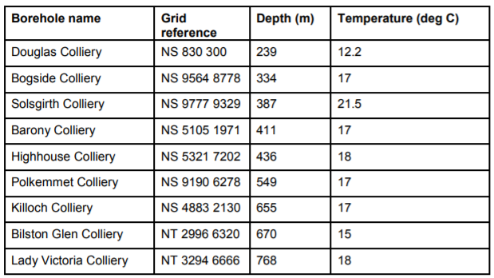

*Temperature at mine boreholes (Gillspie et al., 2013)*

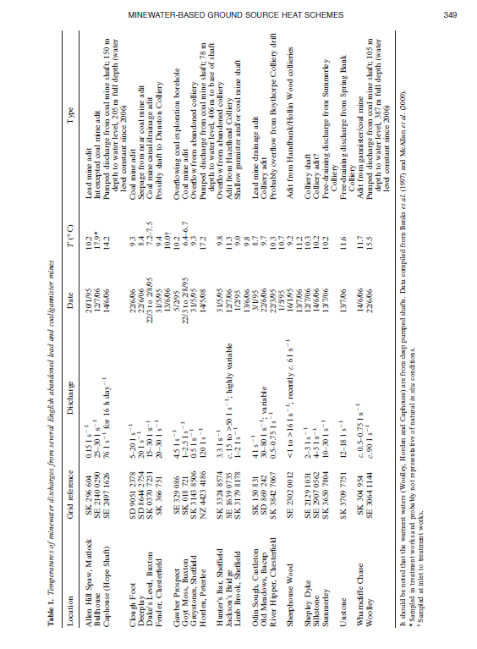

|  |  |  |  |  |  |  |  |
| --- | --- | --- | --- | --- | --- | --- | --- |
| **Borehole name** | **Region** | **Grid reference** | **Source** | **Depth** | **Temp** | **DT** | **Type** |
| Rashiehill | West Midland Valley | NS 8386 7301 | BGS | 964 | 34.4 | 26.2 | LOG |
| Clachie Bridge | West Midland Valley | NS 6447 8368 | BGS | 300 | 13.2 | 16.0 | LOG |
| Salsburgh | West Midland Valley | NS 8166 6486 | GAS | 883 | 30.0 | 24.1 | BHT |
| Hallside | West Midland Valley | NS 6694 5975 | BGS | 350 | 11.8 | 6.0 | LOG |
| Grangemouth | West Midland Valley | NS 9513 8387 | NCB | 1134 | 45.0 | 30.9 | BHT |
| South Balgray | West Midland Valley | NS 50 75 | BEN | 160 | 15.3 | 45.0 | EQM |
| Blythswood | West Midland Valley | NS 5003 6823 | BEN | 105 | 12.0 | 37.1 | EQM |
| Douglas Colliery | West Midland Valley | NS 830 300 | NCB | 239 | 12.2 | 14.2 | MWT |
| Solsgirth Colliery | West Midland Valley | NS 9777 9329 | NCB | 387 | 21.5 | 31.0 | MWT |
| Bogside Colliery | West Midland Valley | NS 9564 8778 | NCB | 334 | 17.0 | 22.2 | MWT |
| Highhouse Colliery | West Midland Valley | NS 5321 7202 | NCB | 436 | 18.0 | 19.5 | MWT |
| Barony Colliery | West Midland Valley | NS 5105 1971 | NCB | 411 | 17.0 | 19.0 | MWT |
| Killoch Colliery | West Midland Valley | NS 4883 2130 | NCB | 655 | 17.0 | 11.9 | MWT |
| Polkemmet Colliery | West Midland Valley | NS 9190 6278 | NCB | 549 | 17.0 | 15.5 | MWT |
| Eggerton | West Midland Valley | NS 8504 3171 | NCB | 410 | 14.0 | 13.2 | BHT |
| Tillicoultry | West Midland Valley | NS 9276 9653 | NCB | 510 | 18.0 | 15.9 | BHT |
| Tullibody | West Midland Valley | NS 8601 9594 | NCB | 325 | 16.0 | 18.8 | BHT |
| Cartlove | West Midland Valley | NS 9403 9267 | NCB | 404 | 16.6 | 16.3 | BHT |
| Gartenkeir | West Midland Valley | NS 9267 9486 | NCB | 488 | 16.0 | 15.0 | BHT |
| Shannock Hill | West Midland Valley | NS 9338 9512 | NCB | 497 | 18.0 | 19.9 | BHT |
| Pipersink | West Midland Valley | NS 9307 8911 | NCB | 408 | 20.2 | 25.5 | BHT |
| Glenochill | West Midland Valley | NS 8769 9617 | NCB | 628 | 30.0 | 32.0 | BHT |
| Queenslie | West Midland Valley | NS 6466 6598 | NCB | 691 | 36.0 | 38.4 | BHT |
| Slatehole | West Midland Valley | NS 4906 2342 | NCB | 1024 | 40.0 | 29.8 | BHT |
| Gallowknowe | West Midland Valley | NS 8388 3118 | NCB | 1261 | 37.5 | 22.8 | BHT |
| Stoneyknowes | West Midland Valley | NS 8817 3570 | BGS | 277 | 13.5 | 18.1 | BHT |
| Craighead | West Midland Valley | NS 8267 6212 | TAW | 977 | 35.0 | 27.2 | BHT |
| Maryhill | West Midland Valley | NS 5718 6856 | IC6 | 303 | 20.0 | 34.0 | EQM |
| Comrie | West Midland Valley | NS 9787 9501 | NCB | 850 | 30.0 | 24.1 | VST |
| Glenrothes | East Midland Valley | NO 2561 0314 | BGS | 279 | 14.4 | 28.1 | EQM |
| Balfour | East Midland Valley | NO 323 003 | BEN | 1205 | 33.4 | 19.8 | EQM |
| Windygates | East Midland Valley | NO 3510 0034 | NCB | 1298 | 30.0 | 16.1 | BHT |
| Spilmersford | East Midland Valley | NT 4570 6902 | BGS | 877 | 27.8 | 20.9 | BHT |
| Midlothian | East Midland Valley | NT 363 647 | ESO | 747 | 37.8 | 39.1 | LOG |
| Birnieknowes | East Midland Valley | NT 7580 7317 | BGS | 372 | 23.9 | 39.2 | LOG |
| Marshall Meadow | East Midland Valley | NT 9797 5686 | IC5 | 227 | 11.5 | 10.6 | EQM |
| Cousland No.5 | East Midland Valley | NT 3774 6773 | BP | 585 | 17.8 | 15.0 | BHT |
| Cousland No.6 | East Midland Valley | NT 3835 6801 | BP | 582 | 23.9 | 25.6 | BHT |
| Pumpherston | East Midland Valley | NT 0733 6979 | BP | 1175 | 36.7 | 23.3 | BHT |
| Lochead | East Midland Valley | NT 3219 9659 | NCB | 1167 | 30.4 | 17.7 | BHT |
| Boreland | East Midland Valley | NT 3040 9420 | AND | 1007 | 29.8 | 20.1 | EQM |
| Mackies Mill | East Midland Valley | NT 3050 9795 | NCB | 960 | 33.3 | 24.6 | BHT |
| Thornton Bridge | East Midland Valley | NT 2889 9722 | NCB | 665 | 28.0 | 27.5 | BHT |
| Thornton Farm | East Midland Valley | NT 2969 9761 | NCB | 1055 | 38.0 | 26.8 | BHT |
| Eastfield | East Midland Valley | NT 3264 7297 | NCB | 1028 | 26.0 | 15.6 | BHT |
| Bilston Glen Colliery | East Midland Valley | NT 2996 6320 | NCB | 670 | 15.0 | 8.7 | MWT |
| Lady Victoria Colliery | East Midland Valley | NT 3294 6666 | NCB | 768 | 18.0 | 10.8 | MWT |
| Auchendinny | East Midland Valley | NT 2496 6125 | NCB | 459 | 18.0 | 19.6 | BHT |
| Wellsgreen | East Midland Valley | NT 3342 9833 | NCB | 1485 | 42.3 | 22.0 | LOG |
| Livingston | East Midland Valley | NT 018 691 | OX3 | 640 | 27.0 | 28.1 | EQM |
| Stewart | East Midland Valley | NT 3633 6476 | LAS | 942 | 37.9 | 34.9 | BHT |
| Frances | East Midland Valley | NT 3214 9050 | NCB | 841 | 29.0 | 23.8 | VST |
| Monktonhall | East Midland Valley | NT 3242 7053 | NCB | 866 | 25.5 | 18.2 | VST |
| Seafield | East Midland Valley | NT 3150 8923 | NCB | 789 | 29.0 | 25.3 | VST |